

**Wachemo University**

**College of Engineering and Technology**

**Department of Software Engineering**

**Project Title:** Design and Development of Wache-Market: An Online Marketplace for Wachemo University

**Name ID**

1. Samuel Tefera 1501240
2. Kedja Ansha 1501019
3. Angelina Melese 1501700
4. Gideon Daniel 1308207
5. Mohammed Belayneh 1510098

**Submitted to:**

**Mr. Feyisa Kedir**  
Instructor, Software Engineering Tools and Practice  
Department of Software Engineering  
Wachemo University

**Acknowledgement**

We would like to express our deepest gratitude to **Mr. Feyisa Kedir**, our instructor for the course *Software Engineering Tools and Practice*, for his unwavering support, guidance, and encouragement throughout the development of this project. His insightful feedback and dedicated mentorship played a vital role in helping us transform our ideas into a fully structured system.

We also extend our sincere thanks to Wachemo University and the Department of Software Engineering for providing us with the resources and learning environment needed to complete this work.

Special appreciation goes to every member of our team for their commitment and collaboration during each stage of this project:

* Samuel Tefera
* Kedija Ansha
* Angelina Melese
* Mohammed Belayneh
* Gideon Daniel

This project would not have been possible without the teamwork, shared knowledge, and mutual support that each member brought to the group. We are proud of what we have achieved together and look forward to applying these experiences in future endeavors.

Table of Contents

Introduction 1

CHAPTER ONE 2

1.1. Requirement Analysis (use cases) 2

1.2. Use case diagram components 5

1.3. Example of use case model 7

1.4. Use case Description/Template 8

1.5. Tools and steps to draw Use Case 25

CHAPTER TWO 29

2.1 High-Level Sequence Diagram 29

2.2 Components of High-Level Sequence Diagram 29

2.3 Example of High-Level Sequence 30

2.4 Tools and Steps to Draw High-Level Sequence Diagram 34

CHAPTER THREE 37

3.1 Low-level (Detail) Design (class design) 37

3.2 Components of the Class Diagram 37

3.3 Example of Class Diagram 38

3.4 Tools and Steps to Draw Low-Level Class Design 39

CHAPTER FOUR 43

4.1 Implementation (export class diagram into code and update code and diagram) 43

4.2 Steps to Generate Code from Class Diagram 44

CHAPTER FIVE 53

5.1 Change Management (Version Control Using Git) 53

5.2 Steps and Tools Used in Our Project to Implement Git 54

CHAPTER SIX 57

6.1 Unit Test 57

6.2 Steps and tools used in Unit Test 58

CHAPTER SEVEN 63

7.1. Build (Prepare Build Script for Compilation, Unit Test, JAR File Creation) 63

7.2. Steps and Tools Used in Our Project to Implement Build 64

References 67

Table 1: Use Case Description – Create Account (UC-001) 9

Table 2: Use Case Description – Login (UC-002) 9

Table 3: Use Case Description – Password Recovery (UC-003) 10

Table 4: Use Case Description – Browse Product (UC-004) 11

Table 5: Use Case Description – Add to Cart (UC-005) 11

Table 6: Use Case Description – Remove from Cart (UC-006) 12

Table 7: Use Case Description – Place Order (UC-007) 12

Table 8: Use Case Description – Make Payment (UC-008) 13

Table 9: Use Case Description – Leave Feedback (UC-009) 14

Table 10: Use Case Description – Manage Product (UC-010) 14

Table 11: Use Case Description – Add Product (UC-011) 15

Table 12: Use Case Description – Edit Product (UC-012) 16

Table 13: Use Case Description – Delete Product (UC-013) 16

Table 14: Use Case Description – View Sales (Seller) (UC-014) 17

Table 15: Use Case Description – View Order History (UC-015) 18

Table 16: Use Case Description – Receive Notification (UC-016) 18

Table 17: Use Case Description – Verify Payment (UC-017) 19

Table 18: Use Case Description – Process Transaction (UC-018) 20

Table 19: Use Case Description – Generate Receipt (UC-019) 20

Table 20: Use Case Description – Manage User (UC-020) 21

Table 21: Use Case Description – Ban Seller (UC-021) 22

Table 22: Use Case Description – Verify Buyer (UC-022) 22

Table 23: Use Case Description – Verify Seller (UC-023) 23

Table 24: Use Case Description – Monitor System Activity (UC-024) 24

Table 25: Use Case Description – View Feedback (UC-026) 24

Table 26: Use Case Description – View Sales (Admin) (UC-027) 25

Table 27: Components of class diagram. 37

Figure 1: Use case diagram for Wache-Market web app. 7

Figure 2: Steps to draw use case digram. 26

Figure 3: Steps to draw use case digram. 26

Figure 4: Steps to draw use case digram. 27

Figure 5: Use case diagram for Wache-Market. 28

Figure 6: Create account sequence diagram. 31

Figure 7: Login sequence diagram. 31

Figure 8: Add product and Delete product sequence diagram. 32

Figure 9: Browse for Product sequence diagram. 32

Figure 10: Purchase a product sequence diagram. 33

Figure 11: Payment method sequence diagram. 33

Figure 12: Steps to draw sequence diagram. 34

Figure 13: Steps to draw sequence diagram. 35

Figure 14: Steps to draw sequence diagram. 35

Figure 15: Steps to draw sequence diagram. 36

Figure 16: Steps to draw class digram. 38

Figure 17: Steps to draw class diagram. 39

Figure 18: Steps to draw class diagram. 40

Figure 19: Steps to draw class diagram. 41

Figure 20: Class diagram for Wache Market. 42

Figure 21: Class diagram used for generating java code. 44

Figure 22: Steps to generate Java code class diagram. 45

Figure 23: Steps to generate Java code class diagram 46

Figure 24: Generated Java code 1. 47

Figure 25: Generated Java code 2. 47

Figure 26: Generated Java code 3. 48

Figure 27: Generated Java code 4. 48

Figure 28: Generated Java code 5. 49

Figure 29: Generated Java code 6. 49

Figure 30: Generated Java code 7. 50

Figure 31: Generated Java code 8. 50

Figure 32: Generated Java code 9. 51

Figure 33: Step to show how to reverse a java code. 52

Figure 34: Link local to remote repository 53

Figure 35: Add and Commit file changes. 54

Figure 36: Push local changes to remote repository 54

Figure 37: Remote repository 55

Figure 38: Contributors on remote repository. 56

Figure 39: Steps to generate test code in java. 58

Figure 40: Steps to draw generate test code in java. 59

Figure 41: Steps to generate test code. 62

Figure 42: Steps to generate java code. 62

Figure 43: Steps to create jar file from java code. 64

Figure 44: Jar file. 65

# Introduction

This document presents the complete software design and development process for **Wache-Market**, a web-based e-commerce system developed by third-year Software Engineering students at Wachemo University. The project aims to provide a user-friendly platform for students, staff, and administrators to buy and sell goods within the university community.

Our system design adheres to established software engineering principles, incorporating comprehensive requirement analysis, use case modeling, high-level and low-level design (UML diagrams), system implementation strategies, version control using Git, unit testing via JUnit, and build automation using Eclipse IDE. Each phase of the Software Development Life Cycle (SDLC) is carefully documented to ensure clarity, traceability, and maintainability of the solution.

The project is tailored to meet the specific needs of Wachemo University users, with functionality that supports secure user authentication, flexible product listings, efficient transaction processing, and role-based access for Buyers, Sellers, and Admins. Through visual modeling tools such as Visual Paradigm and practical implementation in Java, this documentation serves as both a development blueprint and a reference for future enhancements.

# CHAPTER ONE

## 1.1. Requirement Analysis (use cases)

**Requirement analysis** is a critical phase in the systems engineering, software engineering, and project management processes. It involves understanding, documenting, and managing the needs and requirements of stakeholders for a particular project or system.

As a group of 3rd-year Software Engineering students at Wachemo University, we began our web-based e-commerce app project by conducting requirement analysis to understand the needs of our university community, including students and staff. Our aim was to create a platform accessible through a web browser, enabling users to buy and sell products within the Wachemo ecosystem. We gathered requirements through informal interviews with students and staff, a focus group with five classmates. This process helped us compile a comprehensive list of functional and non-functional requirements, which we documented as a team to guide the development of our web app.

Requirement Analysis of Wachemo University E-Commerce System (Wache Mareket):

**Functional Requirement:**

1. User Registration and Login

* Users must be able to register by providing basic information (name, email, phone, password).
* The system must store credentials securely in a MySQL database.
* Registered users must be able to log in using valid credentials.
* Users must receive email or SMS verification before activation.
* The system must allow secure logout from the user session.

2. Account Management

* Users must be able to update their personal information (name, email, password).
* The system must allow users to switch between **buyer** and **seller** modes.
* Users must be able to recover forgotten passwords via email or SMS.
* The system must allow users to view their own profile.

3. Product Browsing and Searching

* Buyers must be able to browse a list of available products.
* The system must allow filtering or searching by category (e.g., books, electronics).
* Product search results must display title, image, price, and availability.
* If no matching product is found, the system must display “No Products Found.”

4. Product Details Viewing

* Buyers must be able to view detailed information about selected products.
* The product details must include title, description, price, and availability (e.g., sold out).

5. Cart Management

* Buyers must be able to add products to their cart from the product page.
* Buyers must be able to remove products from the cart.
* The system must confirm when a product is successfully added or removed.

6. Checkout and Order Placement

* Buyers must be able to proceed to checkout with items in their cart.
* The system must display an order summary and calculate the total cost.
* Buyers must select a payment method and confirm the order.
* The system must handle payment processing and display confirmation.
* If payment fails, the system must display an appropriate error message.

7. Payment and Wallet Integration

* Buyers must be able to use local payment methods (Telebirr, CBE, Amole, M-Pesa).
* The system must support wallet-based deposits and withdrawals.
* Payment transactions must be verified by the system and recorded in the database.
* The system must generate receipts and transaction records for each payment.

8. Product Management (Seller Mode)

* Sellers must be able to add new products with details (title, price, image, category).
* Sellers must be able to edit or delete their products.
* The system must update product availability (e.g., sold out) based on order status.

9. Order Management (Seller Mode)

* Sellers must be able to view all orders placed for their products.
* Sellers must be notified when a new order is placed.

10. Transaction History

* Users must be able to view a list of their past purchases or sales.
* The system must update transaction history after each order or payment is processed.

11. Feedback Submission and Viewing

* Buyers must be able to leave feedback for completed purchases.
* Admins must be able to view all submitted feedback from users.

12. System Administration

* Admins must be able to manage user accounts (verify, ban, or update status).
* Admins must be able to view system logs and platform activity.
* Admins must be able to view product listings, order history, and sales metrics.
* The system must automatically validate inputs and update records as necessary.

13. Payment Verification

* The system must interact with a payment service provider to verify successful transactions.
* If verification fails, the transaction must be marked as unsuccessful.

**Non-Functional Requirements:**

* Security: User data, transactions, and login sessions must be protected with MySQL encryption and safeguards against unauthorized access because of the need to protect sensitive information and prevent data breaches or session hijacking.
* Performance: Web pages must load within 3 seconds, even on university Wi-Fi, and support up to 100 simultaneous users without issues because of the need to ensure a responsive and scalable user experience during peak usage.
* Simplicity: The web interface must be intuitive for all users, regardless of technical skill, with key actions (e.g., adding to cart, toggling modes) requiring minimal steps because of the diverse user base at Wachemo and the need to enhance efficiency and satisfaction.
* Reliability: The system must maintain 99% uptime and handle errors (e.g., payment failures) with clear user feedback because of the requirement for consistent availability and trust in usability.

Scalability: The system must accommodate an increasing number of Wachemo users over time because of anticipated growth in the user base.

## 1.2. Use case diagram components

A **use case diagram** is a visual representation that illustrates the interactions between users (actors) and a system to achieve specific goals. It provides a high-level overview of the system’s functionality from the user’s perspective. The main components of a use case diagram include:

* **Actors**: Represent the external entities that interact with the system. Actors can be human users, external systems, or hardware devices. They are typically depicted as stick figures.
* **Use Cases**: Represent the specific functionalities or services the system provides to its actors. Use cases are shown as ovals with descriptive names inside them, indicating actions or goals the actors can perform.
* **System Boundary**: A rectangle that defines the scope of the system. All use cases are placed within this boundary, showing which functionalities belong to the system.
* **Relationships**: These are lines that connect actors to use cases, and use cases to other use cases. Relationships include:
  + **Association**: A line connecting an actor to a use case, indicating interaction.
  + **Include**: A dashed arrow showing that a use case always includes another use case.
  + **Extend**: A dashed arrow showing that a use case may optionally extend another use case’s behavior.
  + **Generalization**: An arrow indicating inheritance or specialization between actors or between use cases.

Each of these components works together to create a clear and understandable view of how users interact with the system, making it easier to analyze requirements and design the system architecture.

## 1.3. Example of use case model

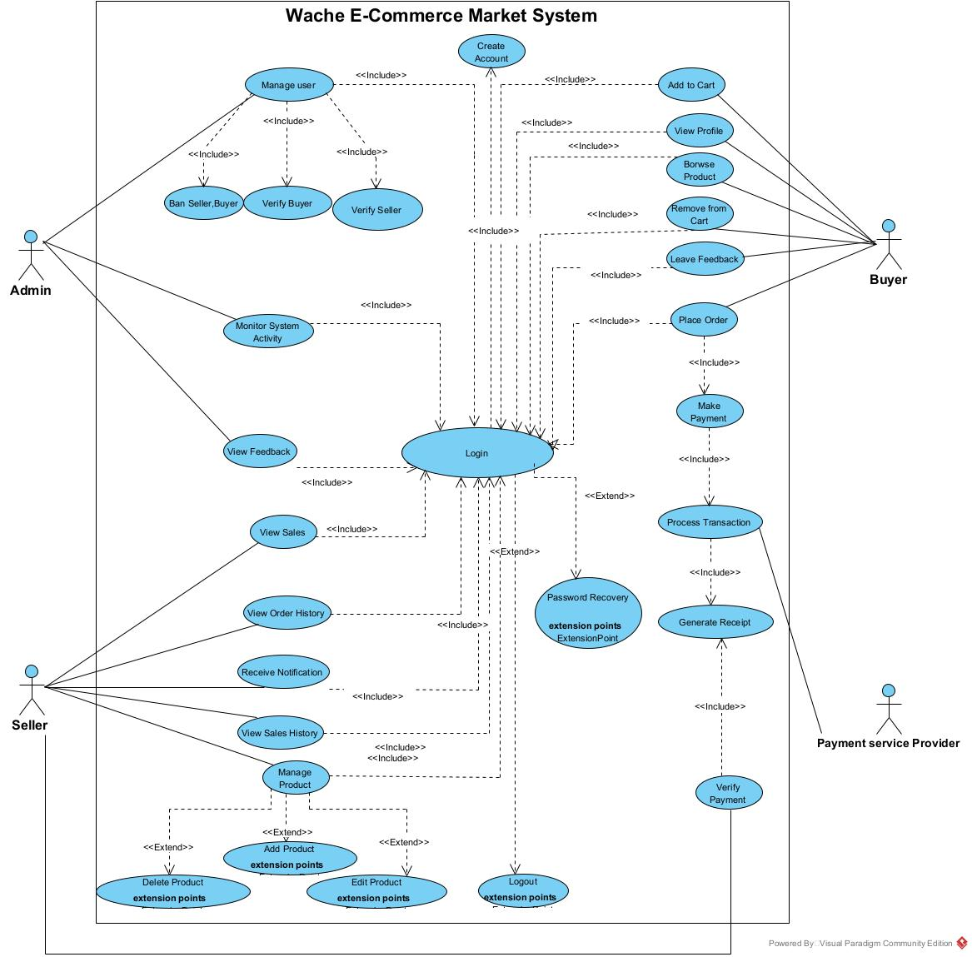

Figure : Use case diagram for Wache-Market web app.

## 1.4. Use case Description/Template

A use case description provides a detailed narrative of how an actor interacts with the system to accomplish a specific goal. It complements the use case diagram by offering step-by-step scenarios for each action.

To ensure consistency, each use case is documented using a standard template that includes the following fields:

|  |  |  |
| --- | --- | --- |
| **Field** | **Description** | |
| **Use Case ID** | UC-001 | |
| **Use Case Name** | Create Account | |
| **Actor** | Buyer | |
| **Summary** | This use case allows the Buyer to create an account on the platform. | |
| **Preconditions** | 1. The Buyer must have access to the platform.  2. The Buyer must not already have an account. | |
| **Trigger** | The Buyer navigates to the registration page and clicks the Register button. | |
| **Basic Scenario** | **Actor Action** | **System Response** |
| **step1.** The Buyer opens the registration page and clicks Register.  **step3.** The Buyer fills out and submits it. | **step2.** The system displays a registration form.  **step4.** The system validates the details. |
| **Verification** | 5. The Buyer receives a verification email or SMS.  6. The system sends a verification email/SMS.  7. The Buyer clicks the verification link or enters the code.  8. The system confirms registration and logs the Buyer in. | |
| **Alternative Scenario** | 9. If invalid details, the system shows an error and prompts correction.  10. If verification is not completed in time, the system deactivates the account. | |
| **Post condition** | The Buyer is registered, and the profile is stored as active upon verification. | |

Table : Use Case Description – Create Account (UC-001)

|  |  |  |
| --- | --- | --- |
| **Field** | **Description** | |
| **Use Case ID** | UC-002 | |
| **Use Case Name** | Login | |
| **Actor** | Buyer / Seller / Admin | |
| **Summary** | This use case allows users to log into the system. | |
| **Preconditions** | 1. The user must have a registered account.2. The user must have access to the platform. | |
| **Trigger** | The user navigates to the login page and enters their credentials. | |
| **Basic Scenario** | **Actor Action** | **System Response** |
| **step1**. The user enters credentials and submits the login form | **step2.** The system validates credentials. |
| **Verification** | 3. The user waits for authentication.  4. The system authenticates the user and grants access. | |
| **Alternative Scenario** | 5. If invalid credentials, the system shows an error.6. If the account is locked, the system shows a message and provides recovery options. | |
| **Post condition** | The user is logged into the system and can access their account features. | |

Table : Use Case Description – Login (UC-002)

|  |  |  |
| --- | --- | --- |
| **Field** | **Description** | |
| **Use Case ID** | UC-003 | |
| **Use Case Name** | Password Recovery | |
| **Actor** | Buyer | |
| **Summary** | This use case allows the Buyer to recover their password if forgotten. | |
| **Preconditions** | 1. The Buyer must have a registered account.  2. The Buyer must have access to their registered email. | |
| **Trigger** | The Buyer clicks the Forgot Password link on the login page. | |
| **Basic Scenario** | **Actor Action** | **System Response** |
| **step1.** The Buyer requests password recovery by providing their email | **step2.** The system validates the email and generates a reset link. |
| **Verification** | 3. The Buyer receives the reset link via email.  4. The system sends the reset link.  5. The Buyer clicks the link and sets a new password.  6. The system updates the password and confirms the change. | |
| **Alternative Scenario** | 7. If the email is invalid, the system shows an error.8. If the reset link expires, the system prompts the Buyer to request a new link. | |
| **Post condition** | The Buyer's password is updated, and they can log in with the new password. | |

Table : Use Case Description – Password Recovery (UC-003)

|  |  |  |
| --- | --- | --- |
| **Field** | **Description** | |
| **Use Case ID** | UC-004 | |
| **Use Case Name** | Browse Product | |
| **Actor** | Buyer | |
| **Summary** | This use case allows the Buyer to browse products available in the marketplace. | |
| **Preconditions** | 1. The Buyer must have access to the platform.  2. Products must be available in the marketplace. | |
| **Trigger** | The Buyer navigates to the product browsing section or searches for products. | |
| **Basic Scenario** | **Actor Action** | **System Response** |
| **step1.** The Buyer searches or navigates to browse products. | **step2.** The system displays a list of available products. |
| **Verification** | 3. The Buyer reviews the product list.4. The system ensures the product list is accurate and up-to-date. | |
| **Alternative Scenario** | 5. If no products are available, the system displays a message indicating no products. | |
| **Post condition** | The Buyer has browsed the products, and the system remains operational. | |

Table : Use Case Description – Browse Product (UC-004)

|  |  |  |
| --- | --- | --- |
| **Field** | **Description** | |
| **Use Case ID** | UC-005 | |
| **Use Case Name** | Add to Cart | |
| **Actor** | Buyer | |
| **Summary** | This use case allows the Buyer to add a product to their shopping cart. | |
| **Preconditions** | 1. The Buyer must be logged into the system.  2. The product must be available in the marketplace. | |
| **Trigger** | The Buyer selects a product and clicks the Add to Cart button. | |
| **Basic Scenario** | **Actor Action** | **System Response** |
| **step1.** The Buyer selects a product and clicks Add to Cart | **step2.** The system adds the product to the Buyer’s cart. |
| **Verification** | 3. The Buyer checks the cart to confirm the product is added.  4. The system updates the cart and displays the updated cart contents. | |
| **Alternative Scenario** | 5. If the product is out of stock, the system displays a message indicating unavailability. | |
| **Post condition** | The product is added to the Buyer’s cart, and the cart is updated in the system. | |

Table : Use Case Description – Add to Cart (UC-005)

|  |  |  |
| --- | --- | --- |
| **Field** | **Description** | |
| **Use Case ID** | UC-006 | |
| **Use Case Name** | Remove from Cart | |
| **Actor** | Buyer | |
| **Summary** | This use case allows the Buyer to remove a product from their shopping cart. | |
| **Preconditions** | 1. The Buyer must be logged into the system.  2. The Buyer’s cart must contain products. | |
| **Trigger** | The Buyer selects a product in the cart and clicks the Remove button. | |
| **Basic Scenario** | **Actor Action** | **System Response** |
| **step1.** The Buyer selects a product in the cart to remove. | **step2.** The system prompts for confirmation. |
| **Verification** | 3. The Buyer confirms the removal.  4. The system updates the cart by removing the selected product. | |
| **Alternative Scenario** | 5. If the Buyer cancels the removal, the system returns to the cart without changes. | |
| **Post condition** | The product is removed from the Buyer’s cart, and the cart is updated in the system. | |

Table : Use Case Description – Remove from Cart (UC-006)

|  |  |  |
| --- | --- | --- |
| **Field** | **Description** | |
| **Use Case ID** | UC-007 | |
| **Use Case Name** | Place Order | |
| **Actor** | Buyer | |
| **Summary** | This use case allows the Buyer to place an order for items in their cart. | |
| **Preconditions** | 1. The Buyer must be logged into the system.  2. The Buyer’s cart must contain items. | |
| **Trigger** | The Buyer clicks the Place Order button from the cart or checkout page. | |
| **Basic Scenario** | **Actor Action** | **System Responses** |
| **step1.** The Buyer confirms the items in the cart and clicks Place Order. | **step2.** The system creates an order and initiates the payment process. |
| **Verification** | 3. The Buyer is redirected to the payment page.  4. The system ensures the order is recorded correctly. | |
| **Alternative Scenario** | 5. If the cart is empty, the system displays a message indicating no items to order. | |
| **Post condition** | The order is placed, and the Buyer is directed to complete the payment. | |

Table : Use Case Description – Place Order (UC-007)

|  |  |  |
| --- | --- | --- |
| **Field** | **Description** | |
| **Use Case ID** | UC-008 | |
| **Use Case Name** | Make Payment | |
| **Actor** | Buyer | |
| **Summary** | This use case allows the Buyer to make a payment for their order. | |
| **Preconditions** | 1. The Buyer must have placed an order.  2. The payment service provider must be available. | |
| **Trigger** | The Buyer is redirected to the payment page after placing an order. | |
| **Basic Scenario** | **Actor Action** | **System Response** |
| **step1**. The Buyer selects a payment method and submits payment details. | **step2.** The system sends the payment details to the payment service provider. |
| **Verification** | 3. The Buyer waits for payment confirmation.  4. The system processes the payment and confirms the transaction status. | |
| **Alternative Scenario** | 5. If the payment fails, the system displays an error and prompts the Buyer to retry with a different method. | |
| **Post condition** | The payment is completed, and the order is marked as paid in the system. | |

Table : Use Case Description – Make Payment (UC-008)

|  |  |  |
| --- | --- | --- |
| **Field** | **Description** | |
| **Use Case ID** | UC-009 | |
| **Use Case Name** | Leave Feedback | |
| **Actor** | Buyer | |
| **Summary** | This use case allows the Buyer to leave feedback for a purchased product or seller. | |
| **Preconditions** | 1. The Buyer must be logged into the system.  2. The Buyer must have completed a purchase. | |
| **Trigger** | The Buyer navigates to the feedback section for a purchased product or seller. | |
| **Basic Scenario** | **Actor Action** | **System Response** |
| **step1**. The Buyer submits feedback for a purchased product or seller. | **step2**. The system validates the feedback content. |
| **Verification** | 3. The Buyer confirms the submission.  4. The system saves the feedback and associates it with the product or seller. | |
| **Alternative Scenario** | 5. If the feedback content is invalid, the system displays an error and prompts for correction. | |
| **Post condition** | The feedback is saved in the system and is available for review by the Admin or Seller. | |

Table : Use Case Description – Leave Feedback (UC-009)

|  |  |  |
| --- | --- | --- |
| **Field** | **Description** | |
| **Use Case ID** | UC-010 | |
| **Use Case Name** | Manage Product | |
| **Actor** | Seller | |
| **Summary** | This use case allows the Seller to manage their products by adding, editing, or deleting them. | |
| **Preconditions** | 1. The Seller must be logged into the system.  2. The Seller must have permission to manage products. | |
| **Trigger** | The Seller navigates to the product management section. | |
| **Basic Scenario** | **Actor Action** | **System Response** |
| **step1.** The Seller initiates the process to manage their products. | **step2**. The system provides options to add, edit, or delete products. |
| **Verification** | 3. The Seller selects an option (add/edit/delete).  4. The system processes the selected action accordingly. | |
| **Alternative Scenario** | 5. If the Seller has no products, the system displays a message indicating no products to manage. | |
| **Post condition** | The Seller’s product inventory is updated based on the action taken. | |

Table : Use Case Description – Manage Product (UC-010)

|  |  |  |
| --- | --- | --- |
| **Field** | **Description** | |
| **Use Case ID** | UC-011 | |
| **Use Case Name** | Add Product | |
| **Actor** | Seller | |
| **Summary** | This use case allows the Seller to add a new product to their inventory. | |
| **Preconditions** | 1. The Seller must be logged into the system.  2. The Seller must have permission to add products. | |
| **Trigger** | The Seller selects the option to add a product from the product management section. | |
| **Basic Scenario** | **Actor Action** | **System Response** |
| **step1.** The Seller submits details of a new product to add. | **step2.** The system validates the product details. |
| **Verification** | 3. The Seller confirms the submission.  4. The system adds the product to the Seller’s inventory and marketplace. | |
| **Alternative Scenario** | 5. If the product details are invalid, the system displays an error and prompts for correction. | |
| **Post condition** | The new product is added to the Seller’s inventory and is available in the marketplace. | |

Table : Use Case Description – Add Product (UC-011)

|  |  |  |
| --- | --- | --- |
| **Field** | **Description** | |
| **Use Case ID** | UC-012 | |
| **Use Case Name** | Edit Product | |
| **Actor** | Seller | |
| **Summary** | This use case allows the Seller to edit an existing product in their inventory. | |
| **Preconditions** | 1. The Seller must be logged into the system.  2. The Seller must have existing products to edit. | |
| **Trigger** | The Seller selects the option to edit a product from the product management section. | |
| **Basic Scenario** | **Actor Action** | **System Response** |
| **step1**. The Seller selects a product and updates its details. | **step2.** The system validates the updated details. |
| **Verification** | 3. The Seller confirms the changes.  4. The system saves the updated product information in the marketplace. | |
| **Alternative Scenario** | 5. If the updated details are invalid, the system displays an error and prompts for correction. | |
| **Post condition** | The product’s details are updated in the Seller’s inventory and the marketplace. | |

Table : Use Case Description – Edit Product (UC-012)

|  |  |  |
| --- | --- | --- |
| **Field** | **Description** | |
| **Use Case ID** | UC-013 | |
| **Use Case Name** | Delete Product | |
| **Actor** | Seller | |
| **Summary** | This use case allows the Seller to delete a product from their inventory. | |
| **Preconditions** | 1. The Seller must be logged into the system.  2. The Seller must have existing products to delete. | |
| **Trigger** | The Seller selects the option to delete a product from the product management section. | |
| **Basic Scenario** | **Actor Action** | **System Response** |
| **step1.** The Seller selects a product to delete. | **step2.** The system prompts for confirmation. |
| **Verification** | 3. The Seller confirms the deletion.  4. The system removes the product from the Seller’s inventory. | |
| **Alternative Scenario** | 5. If the Seller cancels the deletion, the system returns to the product management section without changes. | |
| **Post condition** | The product is removed from the Seller’s inventory and is no longer available in the marketplace. | |

Table : Use Case Description – Delete Product (UC-013)

|  |  |  |
| --- | --- | --- |
| **Field** | **Description** | |
| **Use Case ID** | UC-014 | |
| **Use Case Name** | View Sales (Seller) | |
| **Actor** | Seller | |
| **Summary** | This use case allows the Seller to view their sales data and statistics. | |
| **Preconditions** | 1. The Seller must be logged into the system.  2. Sales data must exist for the Seller. | |
| **Trigger** | The Seller navigates to the sales section. | |
| **Basic Scenario** | **Actor Action** | **System Response** |
| **step1.** The Seller requests to view their sales data. | **step2.** The system retrieves and displays the Seller’s sales statistics. |
| **Verification** | 3. The Seller reviews the sales data.  4. The system ensures the data is accurate and up-to-date. | |
| **Alternative Scenario** | 5. If no sales data is available, the system displays a message indicating no data. | |
| **Post condition** | The Seller has reviewed their sales data, and the system remains operational. | |

Table : Use Case Description – View Sales (Seller) (UC-014)

|  |  |  |
| --- | --- | --- |
| **Field** | **Description** | |
| **Use Case ID** | UC-015 | |
| **Use Case Name** | View Order History | |
| **Actor** | Seller | |
| **Summary** | This use case allows the Seller to view their order history. | |
| **Preconditions** | 1. The Seller must be logged into the system.  2. The Seller must have previous orders. | |
| **Trigger** | The Seller navigates to the order history section. | |
| **Basic Scenario** | Actor Action | System Response |
| **step1**. The Seller requests to view their order history. | **step2.** The system retrieves and displays the Seller’s order history. |
| **Verification** | 3. The Seller reviews the order history.  4. The system ensures all orders are displayed correctly. | |
| **Alternative Scenario** | 5. If no orders exist, the system displays a message indicating no order history. | |
| **Post condition** | The Seller has reviewed their order history, and the system remains operational. | |

Table : Use Case Description – View Order History (UC-015)

|  |  |  |
| --- | --- | --- |
| **Field** | **Description** | |
| **Use Case ID** | UC-016 | |
| **Use Case Name** | Receive Notification | |
| **Actor** | Seller | |
| **Summary** | This use case allows the Seller to receive notifications about orders or account updates. | |
| **Preconditions** | 1. The Seller must be logged into the system.  2. Notifications must exist for the Seller. | |
| **Trigger** | The Seller logs in or navigates to the notifications section. | |
| **Basic Scenario** | **Actor Action** | **System Response** |
| **step1.** The Seller logs in to check for notifications. | **step2**. The system displays notifications about orders or account updates. |
| **Verification** | 3. The Seller reviews the notifications.  4. The system ensures all notifications are displayed correctly. | |
| **Alternative Scenario** | 5. If no notifications exist, the system displays a message indicating no notifications. | |
| **Post condition** | The Seller has reviewed their notifications, and the system remains operational. | |

Table : Use Case Description – Receive Notification (UC-016)

|  |  |  |
| --- | --- | --- |
| **Field** | **Description** | |
| **Use Case ID** | UC-017 | |
| **Use Case Name** | Verify Payment | |
| **Actor** | Payment Service Provider | |
| **Summary** | This use case allows the Payment Service Provider to verify payment details for a transaction. | |
| **Preconditions** | 1. The Buyer must have submitted payment details.  2. The Payment Service Provider must be operational. | |
| **Trigger** | The system submits payment details to the Payment Service Provider for verification. | |
| **Basic Scenario** | **Actor Action** | **System Response** |
| **step1.** The system submits payment details for verification. | **step2.** The Payment Service Provider verifies the payment details. |
| **Verification** | 3. The system waits for verification status.  4. The Payment Service Provider confirms the payment status (valid/invalid). | |
| **Alternative Scenario** | 5. If the payment details are invalid, the Payment Service Provider returns an error, and the system prompts the Buyer to correct the details. | |
| **Post condition** | The payment is verified, and the system proceeds with the transaction process. | |

Table : Use Case Description – Verify Payment (UC-017)

|  |  |  |
| --- | --- | --- |
| **Field** | **Description** | |
| **Use Case ID** | UC-018 | |
| **Use Case Name** | Process Transaction | |
| **Actor** | Payment Service Provider | |
| **Summary** | This use case allows the Payment Service Provider to process a transaction for the Buyer’s order. | |
| **Preconditions** | 1. The Buyer must have submitted payment details.  2. The Payment Service Provider must be operational. | |
| **Trigger** | The system sends transaction details to the Payment Service Provider after the Buyer submits payment. | |
| **Basic Scenario** | **Actor Action** | **System Response** |
| **step1.** The system sends transaction details to the Payment Service Provider. | **step2.** The Payment Service Provider processes the transaction. |
| **Verification** | 3. The system waits for the transaction status.  4. The Payment Service Provider returns the transaction status (success/failure). | |
| **Alternative Scenario** | 5. If the transaction fails, the Payment Service Provider returns an error, and the system prompts the Buyer to retry. | |
| **Post condition** | The transaction is processed, and the system updates the order status based on the result. | |

Table : Use Case Description – Process Transaction (UC-018)

|  |  |  |
| --- | --- | --- |
| **Field** | **Description** | |
| **Use Case ID** | UC-019 | |
| **Use Case Name** | Generate Receipt | |
| **Actor** | Payment Service Provider | |
| **Summary** | This use case allows the Payment Service Provider to generate a receipt for a successful transaction. | |
| **Preconditions** | 1. The transaction must be successfully processed.  2. The Payment Service Provider must support receipt generation. | |
| **Trigger** | The system requests a receipt after a successful transaction. | |
| **Basic Scenario** | **Actor Action** | **System Response** |
| **step1.** The system requests a receipt from the Payment Service Provider. | **step2.** The Payment Service Provider generates the receipt. |
| **Verification** | 3. The system receives the receipt.  4. The Payment Service Provider sends the receipt to the system. | |
| **Alternative Scenario** | 5. If receipt generation fails, the system logs the error and notifies the Buyer of the transaction without a receipt. | |
| **Post condition** | The receipt is generated and stored in the system, and the Buyer receives a copy. | |

Table : Use Case Description – Generate Receipt (UC-019)

|  |  |  |
| --- | --- | --- |
| **Field** | **Description** | |
| **Use Case ID** | UC-020 | |
| **Use Case Name** | Manage User | |
| **Actor** | Admin | |
| **Summary** | This use case allows the Admin to manage user accounts by banning or verifying buyers and sellers. | |
| **Preconditions** | 1. The Admin must be logged into the system with appropriate permissions.  2. The system must have user accounts available to manage. | |
| **Trigger** | The Admin navigates to the user management section of the system. | |
| **Basic Scenario** | **Actor Action** | **System Response** |
| **step1.** The Admin navigates to the user management section. | **step2**. The system displays a list of users with options to ban or verify. |
| **Verification** | 3. The Admin selects a user and chooses an action (ban/verify).  4. The system updates the user’s status and confirms the action. | |
| **Alternative Scenario** | 5. If the user list is empty, the system displays a message indicating no users are available. | |
| **Post condition** | The user’s status is updated in the system, and the Admin is notified of the successful action. | |

Table : Use Case Description – Manage User (UC-020)

|  |  |  |
| --- | --- | --- |
| **Field** | **Description** | |
| **Use Case ID** | UC-021 | |
| **Use Case Name** | Ban Seller | |
| **Actor** | Admin | |
| **Summary** | This use case allows the Admin to ban a seller from the platform. | |
| **Preconditions** | 1. The Admin must be logged into the system.  2. The seller must have an active account. | |
| **Trigger** | The Admin selects the option to ban a seller from the user management section. | |
| **Basic Scenario** | **Actor Action** | **System Response** |
| **step1**. The Admin selects a seller to ban. | **step2.** The system prompts for confirmation. |
| **Verification** | 3. The Admin confirms the action.  4. The system updates the seller's status to banned and notifies the seller. | |
| **Alternative Scenario** | 5. If the Admin cancels the action, the system returns to the user management section without changes. | |
| **Post condition** | The seller's account is banned, and they can no longer access the platform. | |

Table : Use Case Description – Ban Seller (UC-021)

|  |  |  |
| --- | --- | --- |
| **Field** | **Description** | |
| **Use Case ID** | UC-022 | |
| **Use Case Name** | Verify Buyer | |
| **Actor** | Admin | |
| **Summary** | This use case allows the Admin to verify a buyer's account. | |
| **Preconditions** | 1. The Admin must be logged into the system.  2. The buyer must have an unverified account. | |
| **Trigger** | The Admin selects the option to verify a buyer from the user management section. | |
| **Basic Scenario** | **Actor Action** | **System Response** |
| **step1.** The Admin selects a buyer to verify. | **step2.** The system prompts for confirmation. |
| **Verification** | 3. The Admin confirms the action.  4. The system marks the buyer as verified and updates their profile. | |
| **Alternative Scenario** | 5. If the Admin cancels the action, the system returns to the user management section without changes. | |
| **Post condition** | The buyer's account is verified, granting them full access to platform features. | |

Table : Use Case Description – Verify Buyer (UC-022)

|  |  |  |
| --- | --- | --- |
| **Field** | **Description** | |
| **Use Case ID** | UC-023 | |
| **Use Case Name** | Verify Seller | |
| **Actor** | Admin | |
| **Summary** | This use case allows the Admin to verify a seller's account. | |
| **Preconditions** | 1. The Admin must be logged into the system.  2. The seller must have an unverified account. | |
| **Trigger** | The Admin selects the option to verify a seller from the user management section. | |
| **Basic Scenario** | **Actor Action** | **System Response** |
| **step1.** The Admin selects a seller to verify. | **step2**. The system prompts for confirmation. |
| **Verification** | 3. The Admin confirms the action.  4. The system marks the seller as verified and updates their profile. | |
| **Alternative Scenario** | 5. If the Admin cancels the action, the system returns to the user management section without changes. | |
| **Post condition** | The seller's account is verified, granting them full access to platform features. | |

Table : Use Case Description – Verify Seller (UC-023)

|  |  |  |
| --- | --- | --- |
| **Field** | **Description** | |
| **Use Case ID** | UC-025 | |
| **Use Case Name** | Monitor System Activity | |
| **Actor** | Admin | |
| **Summary** | This use case allows the Admin to monitor system activity, including user actions and metrics. | |
| **Preconditions** | 1. The Admin must be logged into the system.  2. The system must have activity logs available. | |
| **Trigger** | The Admin navigates to the system monitoring dashboard. | |
| **Basic Scenario** | **Actor Action** | **System Response** |
| **step1.** The Admin accesses the system monitoring dashboard. | **step2.** The system displays activity logs, user actions, and metrics. |
| **Verification** | 3. The Admin reviews the logs and metrics.  4. The system ensures the data is up-to-date and accurate. | |
| **Alternative Scenario** | 5. If no activity logs are available, the system displays a message indicating no data. | |
| **Post condition** | The Admin has reviewed the system activity, and the system remains operational. | |

Table : Use Case Description – Monitor System Activity (UC-024)

|  |  |  |
| --- | --- | --- |
| **Field** | **Description** | |
| **Use Case ID** | UC-026 | |
| **Use Case Name** | View Feedback | |
| **Actor** | Admin | |
| **Summary** | This use case allows the Admin to view feedback left by buyers. | |
| **Preconditions** | 1. The Admin must be logged into the system.  2. Feedback must exist in the system. | |
| **Trigger** | The Admin navigates to the feedback section. | |
| **Basic Scenario** | **Actor Action** | **System Response** |
| **step1.** The Admin requests to view feedback from buyers. | **step2**. The system retrieves and displays feedback. |
| **Verification** | 3. The Admin reviews the feedback.  4. The system ensures all feedback is displayed correctly. | |
| **Alternative Scenario** | 5. If no feedback is available, the system displays a message indicating no feedback. | |
| **Post condition** | The Admin has reviewed the feedback, and the system remains operational. | |

Table : Use Case Description – View Feedback (UC-026)

|  |  |  |
| --- | --- | --- |
| **Field** | **Description** | |
| **Use Case ID** | UC-027 | |
| **Use Case Name** | View Sales (Admin) | |
| **Actor** | Admin | |
| **Summary** | This use case allows the Admin to view sales data and statistics. | |
| **Preconditions** | 1. The Admin must be logged into the system.  2. Sales data must exist in the system. | |
| **Trigger** | The Admin navigates to the sales section. | |
| **Basic Scenario** | **Actor Action** | **System Response** |
| **step1.** The Admin requests to view sales data | **step2**. The system retrieves and displays sales statistics and reports. |
| **Verification** | 3. The Admin reviews the sales data.  4. The system ensures the data is accurate and up-to-date. | |
| **Alternative Scenario** | 5. If no sales data is available, the system displays a message indicating no data. | |
| **Post condition** | The Admin has reviewed the sales data, and the system remains operational. | |

Table : Use Case Description – View Sales (Admin) (UC-027)

## 1.5. Tools and steps to draw Use Case

For drawing the use case diagram, we used **Visual Paradigm**, a user-friendly UML modeling tool that helps create clear and standardized diagrams.

The steps followed were:

* Open Visual Paradigm and create a new project.
* Select **Use Case Diagram** from the available diagram types.
* Add the main actors (Admin, Seller, Buyer) using the actor symbols.

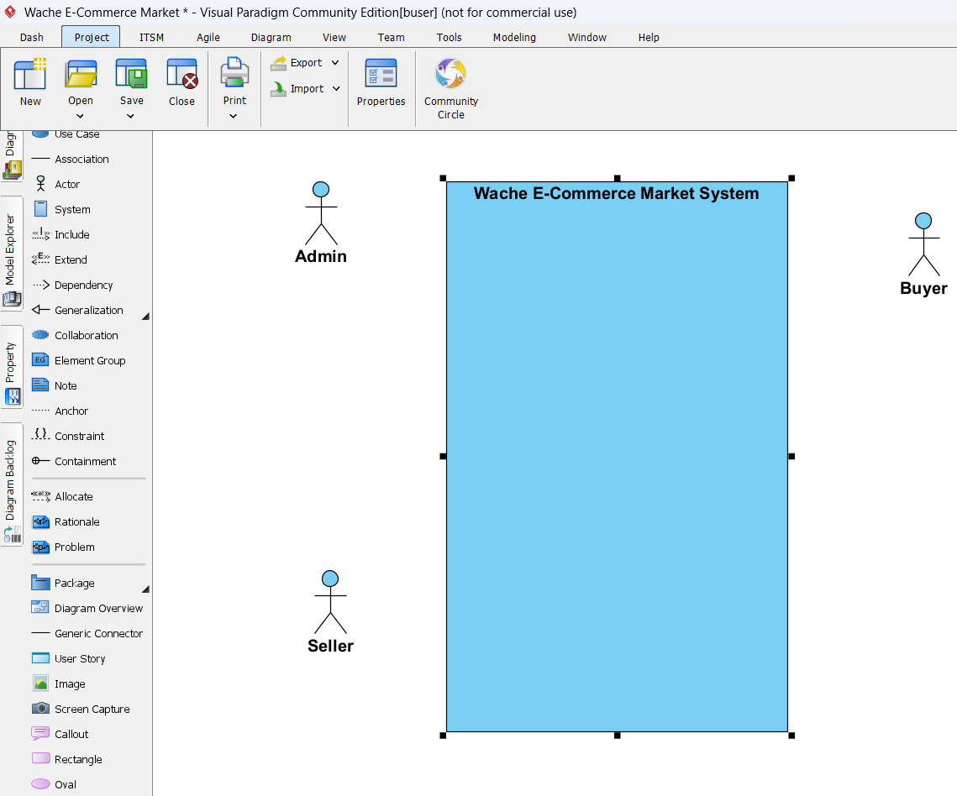

Figure : Steps to draw use case digram.

* Insert the use cases (e.g., Login, Create Account, Browse Product) using ellipse shapes.

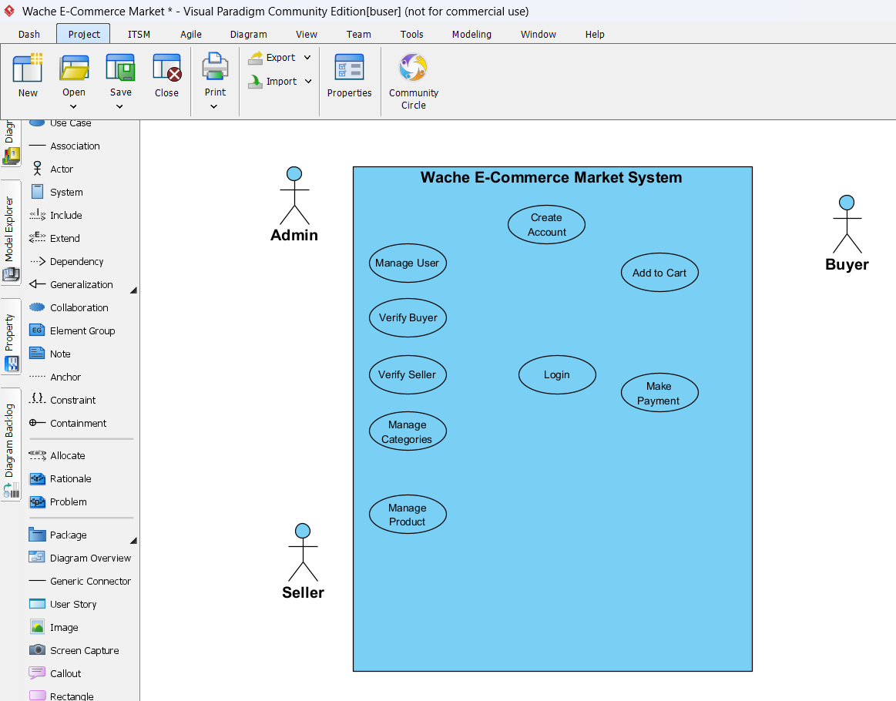

Figure : Steps to draw use case digram.

* Draw association lines between actors and use cases.
* Apply the **<<include>>** and **<<extend>>** relationships where needed.

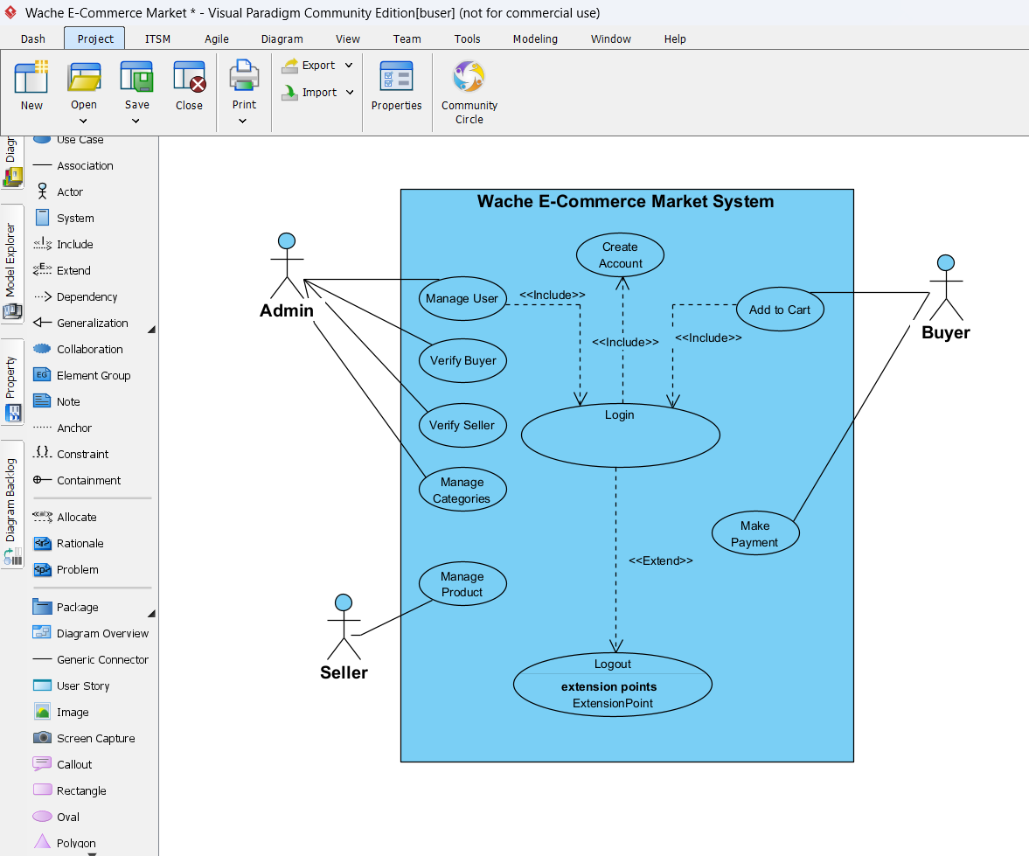

Figure : Steps to draw use case digram.

* Arrange the diagram layout neatly for readability.
* Save and export the diagram as an image for documentation.



Figure : Use case diagram for Wache-Market.

# CHAPTER TWO

## 2.1 High-Level Sequence Diagram

In this section, we present the high-level sequence diagram for the Wache E-Commerce Market System. This diagram shows the interactions between key system components (such as Buyer, Seller, Admin) for major use cases like product browsing, adding to cart, managing products, and completing payments.

The purpose of the high-level sequence diagram is to capture the overall flow of messages and interactions between actors and system components, without diving into detailed class-level interactions.

## ****2.2 Components of High-Level Sequence Diagram****

A high-level sequence diagram is made up of several key components that together describe how actors and system parts interact over time to accomplish a specific process or use case. Below are the main components typically found in a high-level sequence diagram:

* **Actors:** External entities that interact with the system, such as users (Buyer, Seller, Admin) or external services. They initiate or respond to system messages.
* **System Components (Objects):** The main parts of the system that handle specific tasks, such as the Product Catalog, Cart, Payment Gateway, User Account, or Order Management module.
* **Lifelines:** Vertical dashed lines extending from each actor or system component. These represent the time dimension, showing that the actor or component exists and can send or receive messages during the interaction.
* **Messages:** Horizontal arrows that represent communication between lifelines. Messages can be:
  + **Synchronous** (with a waiting reply, like a database query)
  + **Asynchronous** (without waiting, like sending a notification) These show the sequence of operations, such as “add product to cart” or “process payment.”
* **Activation Bars (Execution Occurrences):** Thin vertical rectangles drawn on lifelines, showing when a component is actively doing something (executing an operation or waiting for a reply).
* **Return Messages:** Dashed arrows showing the response or result of an earlier message, such as a confirmation or error.
* **Sequence Flow:** The top-to-bottom order of the diagram, where interactions are arranged chronologically, helping viewers understand the process flow over time.

These components together provide a clear picture of how various parts of the system work together to fulfill a high-level process, allowing stakeholders to trace the interaction steps and understand system behavior.

## 2.3 Example of High-Level Sequence

A high-level sequence diagram demonstrates the interaction between major system components or actors in a specific process. It presents the flow of messages in a sequential order, emphasizing how the system behaves from a broader perspective without focusing on technical implementation details.

This type of diagram is particularly useful for visualizing how different parts of the system collaborate to achieve a goal. It helps stakeholders quickly grasp the overall process, communication flow, and responsibilities of each component.

The following diagram(s) illustrate a high-level sequence based on the selected use case(s) of the system:

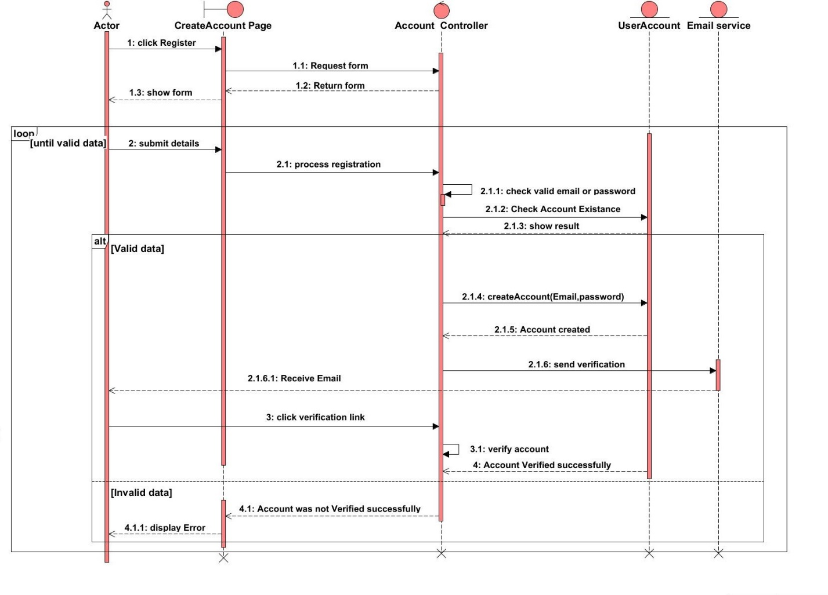

Figure : Create account sequence diagram.

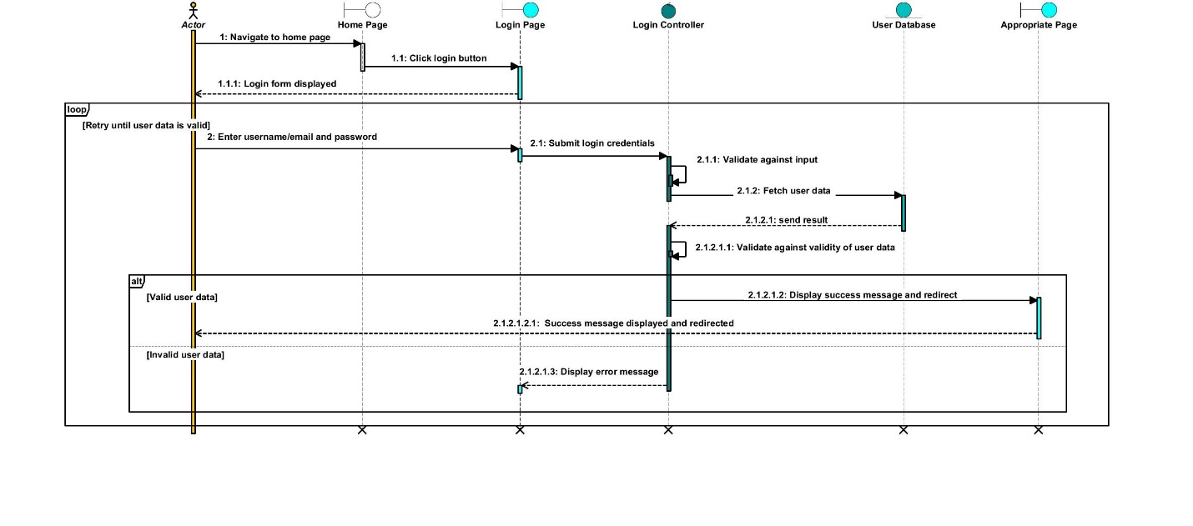

Figure : Login sequence diagram.

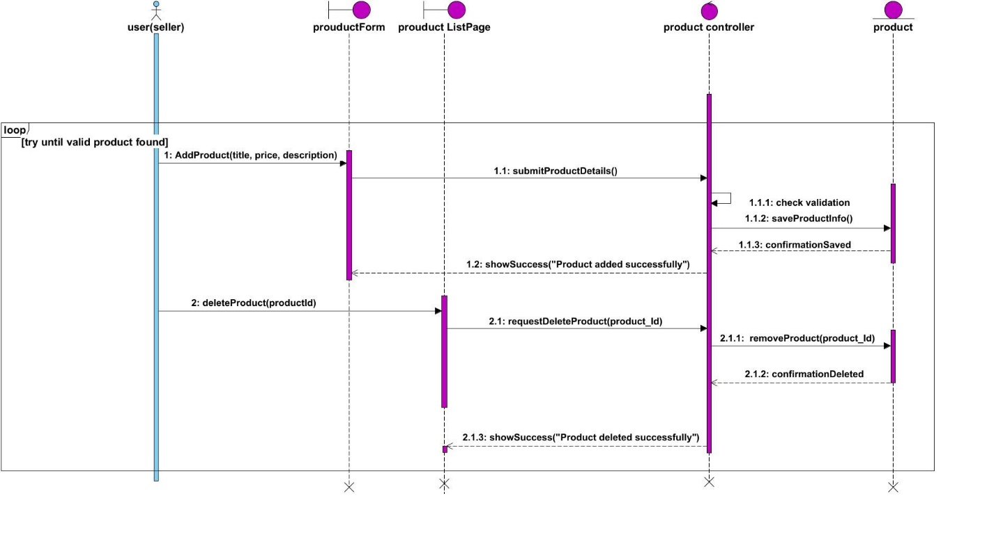

Figure : Add product and Delete product sequence diagram.

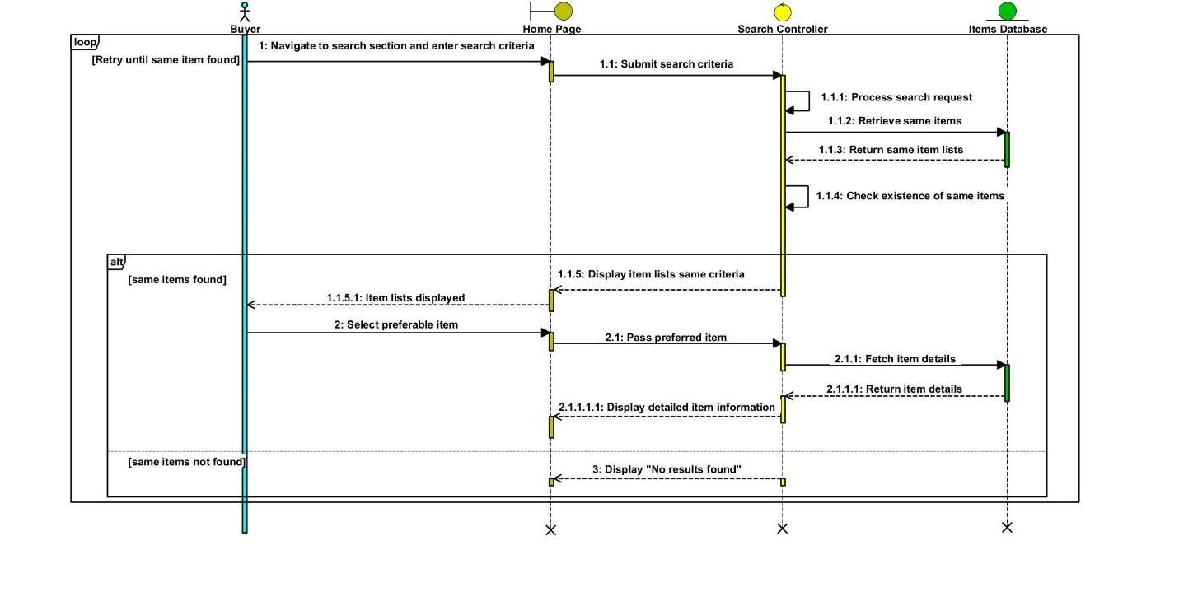

Figure : Browse for Product sequence diagram.

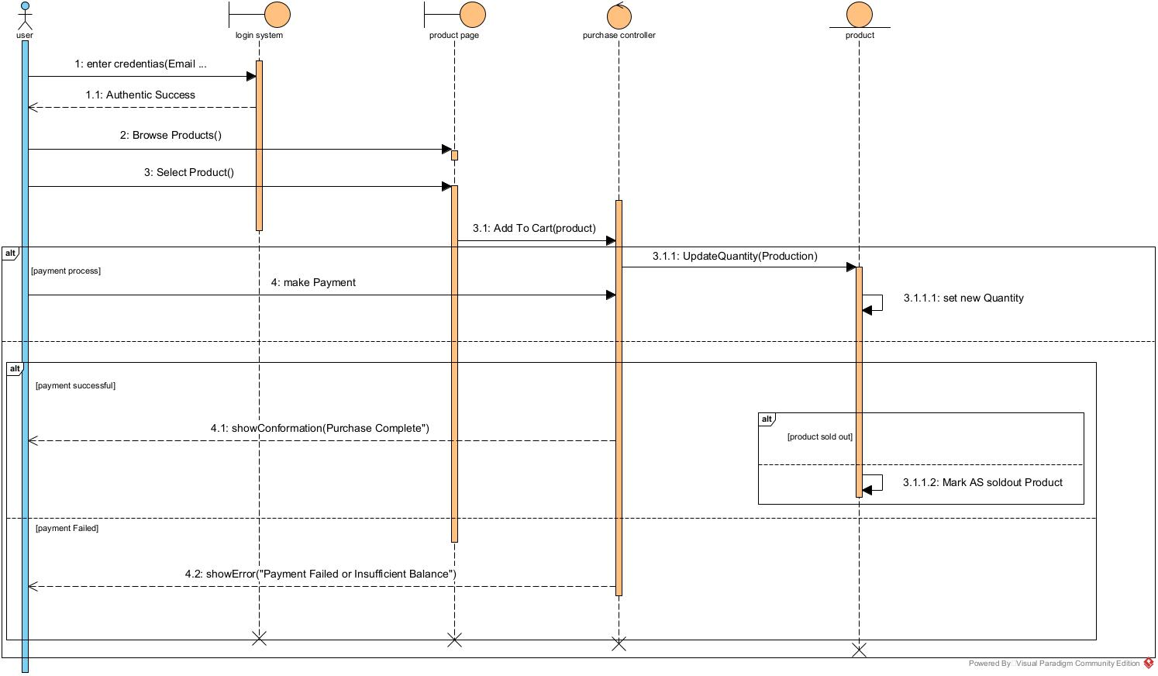

Figure : Purchase a product sequence diagram.

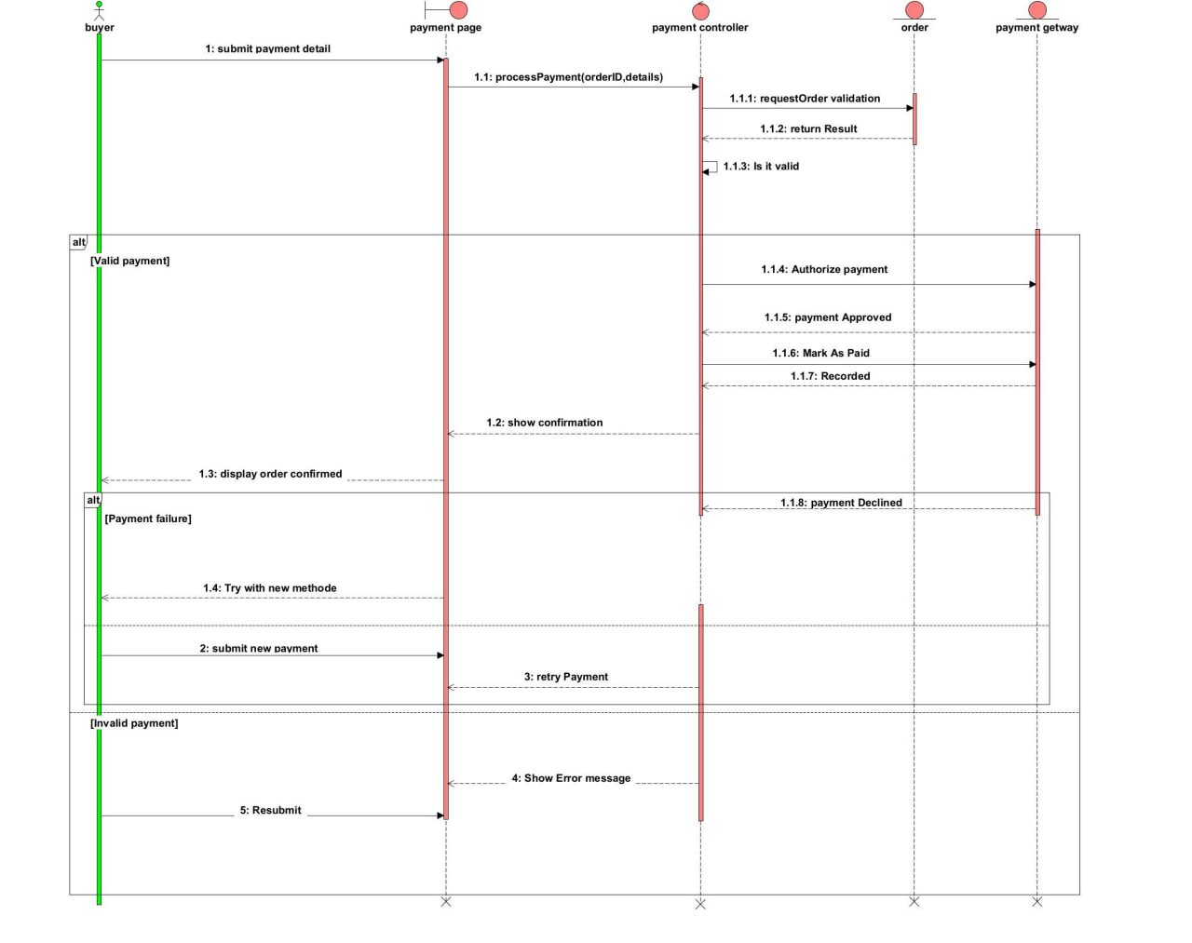

Figure : Payment method sequence diagram.

### 2.4 Tools and Steps to Draw High-Level Sequence Diagram

High-level sequence diagrams can be effectively created using modeling tools such as **Visual Paradigm**, which supports intuitive drag-and-drop functionality and UML-compliant diagramming.

**Steps to Create a High-Level Sequence Diagram Using Visual Paradigm:**

1. **Open Visual Paradigm**  
   Launch the tool and create a new UML project or open an existing one.
2. **Select Sequence Diagram**  
   From the diagram toolbar, choose the sequence diagram option.

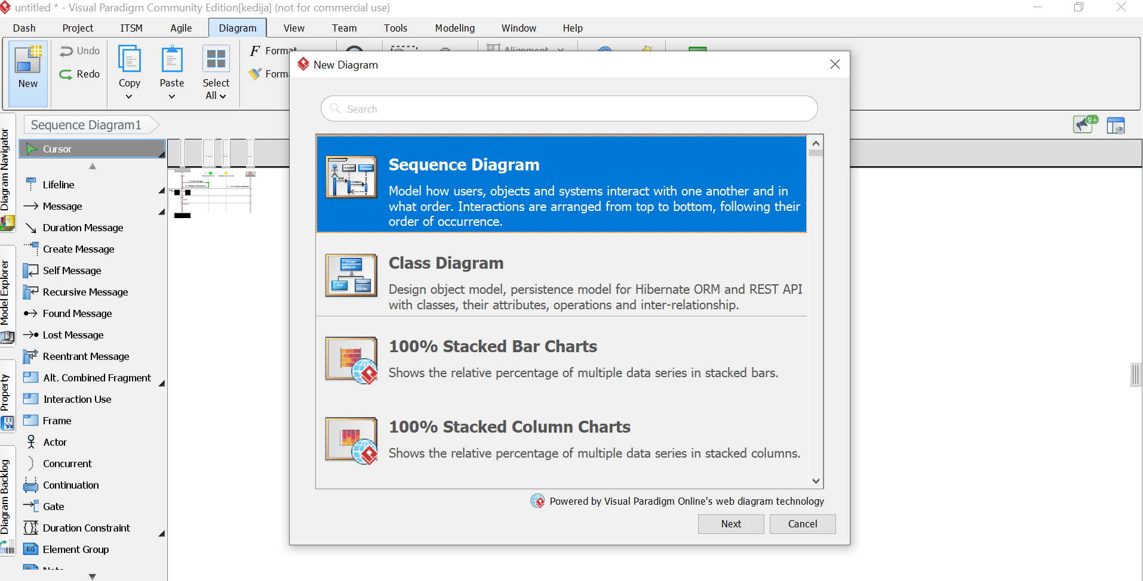

Figure : Steps to draw sequence diagram.

1. **Identify and Add Lifelines**  
   Add lifelines to represent the main actors or system components involved in the process.

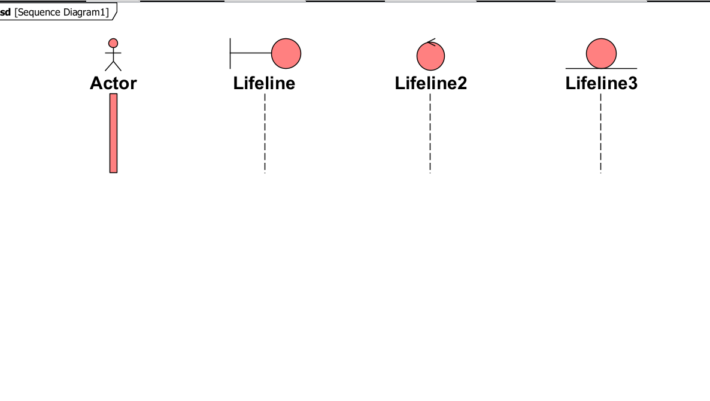

Figure : Steps to draw sequence diagram.

1. **Define Interactions**  
   Draw messages between the lifelines in the order they occur. Focus on the main interactions relevant to the high-level process.
2. **Avoid Technical Details**  
   Keep the diagram at an abstract level by avoiding internal logic, loops, or complex operations. Use simple and clear messages.

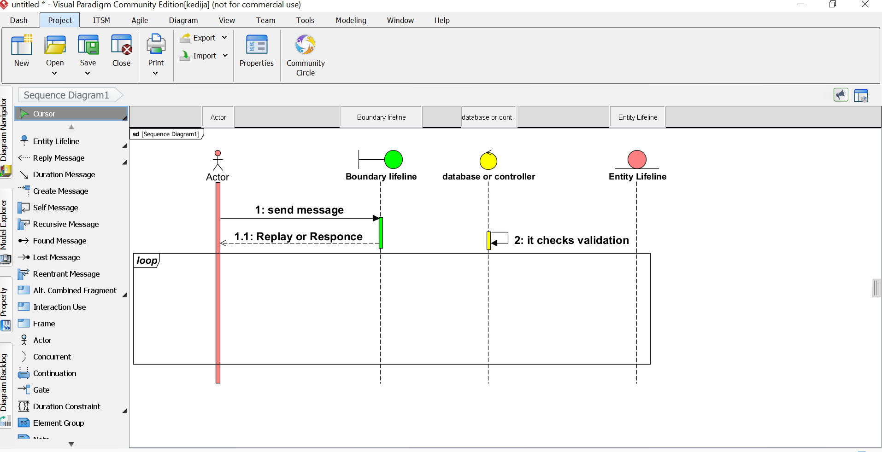

Figure : Steps to draw sequence diagram.

1. **Label Clearly**  
   Ensure all lifelines and messages are labeled appropriately for easy understanding.

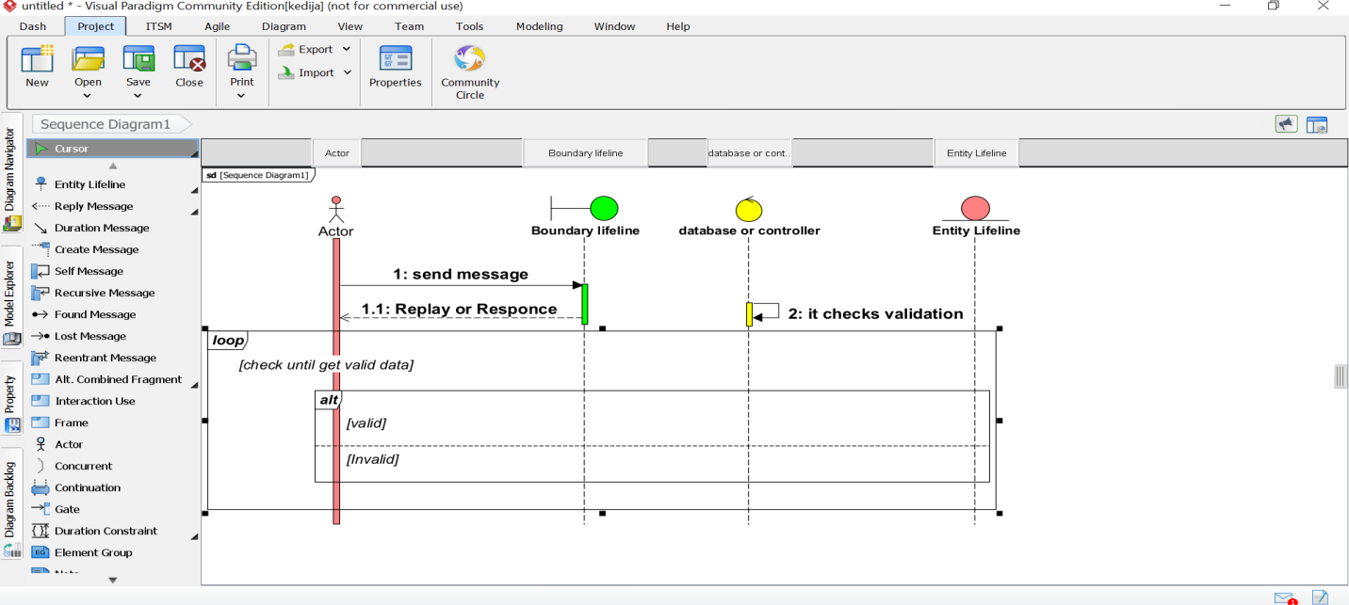

Figure : Steps to draw sequence diagram.

1. **Review and Finalize**  
   Validate the logical flow of interactions, make necessary adjustments, and save or export the diagram for documentation purposes.

By following these steps in Visual Paradigm, high-level sequence diagrams can be efficiently created to support system analysis, design, and communication among stakeholders.

# CHAPTER THREE

## 3.1 Low-level (Detail) Design (class design)

Low-level design focuses on the internal structure of each module or component. At this level, the design addresses how each function and feature will be implemented within the system classes. For the e-commerce system, the class design identifies the key classes like User, Product, Order, Transaction, and the roles Buyer, Seller, and Admin, each with their own responsibilities and behaviors.

**Each class includes:**

* **Attributes**: Representing data stored (e.g., name, email, product price)
* **Methods**: Defining operations or behaviors (e.g., login(), checkout(), addToCart())

The class diagram illustrates object-oriented principles such as inheritance (Buyer, Seller, Admin inherit from User) and associations (e.g., Order has a relation with Product and Buyer).

## 3.2 Components of the Class Diagram

A UML class diagram typically contains the following components:

|  |  |
| --- | --- |
| **Component** | **Description** |
| **Class** | A blueprint for objects, showing attributes and methods. |
| **Attributes** | Variables that hold the data or state of the class. |
| **Methods** | Functions that define the class behavior. |
| **Relationships** | Links between classes such as:  - **Association**: Simple link between classes  - **Aggregation/Composition**: Whole-part relationships  - **Generalization**: Inheritance relationship (is-a) |
| **Visibility** | Symbols: + public, - private, # protected |
| **Multiplicity** | Indicates number of instances (e.g., 1, 0..*, 1..*, etc.) |

Table : Components of class diagram.

## 3.3 Example of Class Diagram

The following class diagram, created using **Visual Paradigm**, represents the detailed object-oriented structure of the e-commerce system. It illustrates key entities such as User, Buyer, Seller, Admin, Product, Order, Cart, and their relationships.

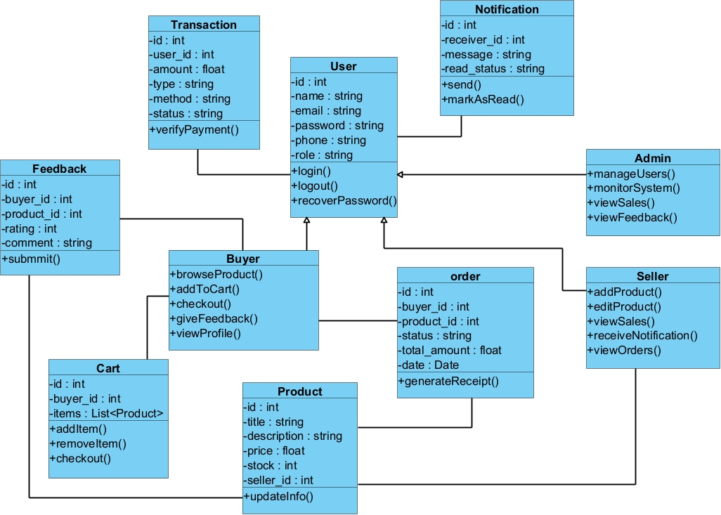

Figure : Steps to draw class digram.

This diagram visually expresses:

* **Inheritance** relationships (e.g., Buyer, Seller, and Admin inherit from User)
* **Associations** between classes (e.g., Order is linked to both Buyer and Product)
* **Attributes and methods** for each class, reflecting system functionality

This class-level model provides a blueprint for implementation and ensures modularity and reusability.

## 3.4 Tools and Steps to Draw Low-Level Class Design

Creating a detailed class design is a crucial step in object-oriented system development. Here’s how this was approached using **Visual Paradigm**:

**Tool Used**

**Visual Paradigm**: A powerful UML tool for drawing class diagrams

**Steps to Create the Class Diagram**

1. Identify Key Entities

Based on use cases (e.g., User, Product, Order, Transaction)

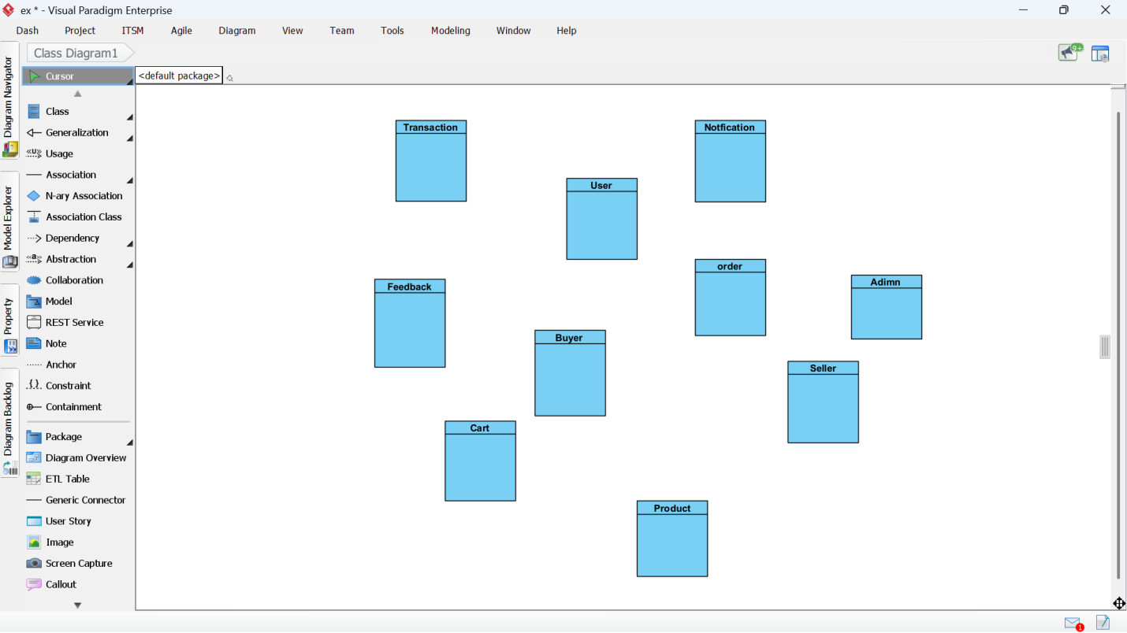

Figure : Steps to draw class diagram.

1. Define Relationships

Model inheritance, associations, and multiplicity between entities

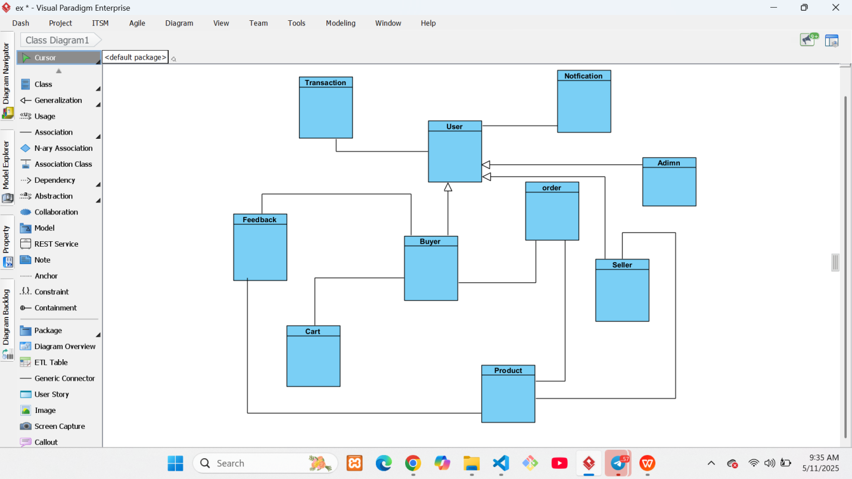

Figure : Steps to draw class diagram.

1. Add Attributes and Methods

Each class includes relevant fields (e.g., email, price) and functions (e.g., login(), checkout())

1. Apply Object-Oriented Principles

Use generalization for inheritance, encapsulate fields, and keep cohesion

Ensure symbols for visibility (+, -) and relationships follow UML conventions

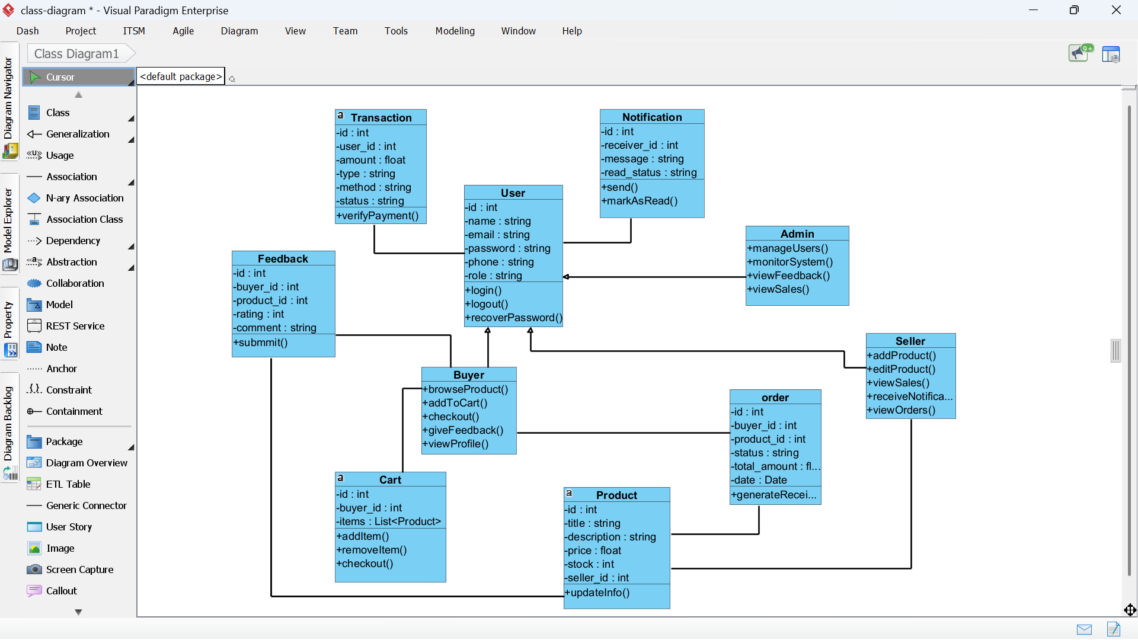

Figure : Steps to draw class diagram.

1. Export and Validate  
   Diagram is reviewed for accuracy and exported as an image or embedded in documentation



Figure : Class diagram for Wache Market.

This low-level design lays the foundation for coding and database modeling by ensuring clear and consistent object structures.

# CHAPTER FOUR

## 4.1 Implementation (export class diagram into code and update code and diagram)

The class diagram created in Visual Paradigm was used as the basis for generating the initial source code structure of the e-commerce system. This process not only speeds up development but also ensures consistency between design and implementation.

**Code Generation from Class Diagram**

Using Visual Paradigm’s **Code Engineering** feature, the class diagram was exported into the target programming language (e.g., Java). The generated code included:

* Class declarations
* Attributes with proper data types
* Method stubs (without implementation)

This provided a **scaffold** that developers could immediately build upon.

**Updating Code and Diagram**

As the project evolved, the following steps were taken to maintain alignment:

* When **new attributes or methods** were added in code, they were **manually added back into the diagram**
* If relationships changed (e.g., new association between Transaction and Product), they were **reflected visually**
* Visual Paradigm’s **reverse engineering** feature was occasionally used to **update diagrams based on code**

This ensured continuous **synchronization** between documentation and implementation throughout development.

## 4.2 Steps to Generate Code from Class Diagram

The following steps outline how code was generated from the class diagram using **Visual Paradigm**:

Step 1: Finalize the Class Diagram

Ensure that the class diagram includes:

* All relevant classes, attributes, and methods
* Relationships like associations and inheritance
* Correct visibility modifiers (e.g., public, private)



Figure : Class diagram used for generating java code.

Step 2: Access Instant Generator

Navigate to:

**Tools > Code > Instant Generator**

This opens the code generation panel.

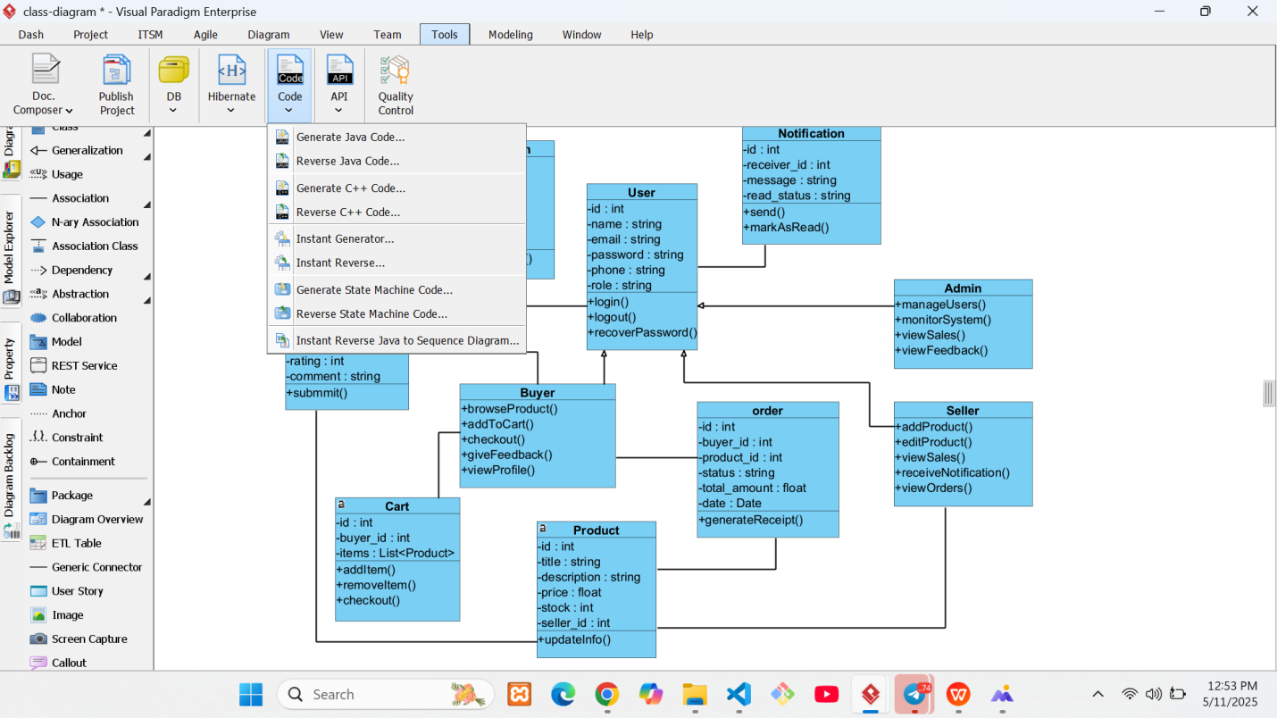

Figure : Steps to generate Java code class diagram.

Step 3: Configure Generation Options

In the generator window:

* **Model**: Select the entire diagram or specific classes
* **Language**: Choose the target programming language (Java, Python, PHP, etc.)
* **Output Path**: Define the folder where the generated files will be saved

Optional configurations:

* Choose whether to generate comments or method bodies
* Enable or disable getter/setter generation
* Set package structure or namespace if needed

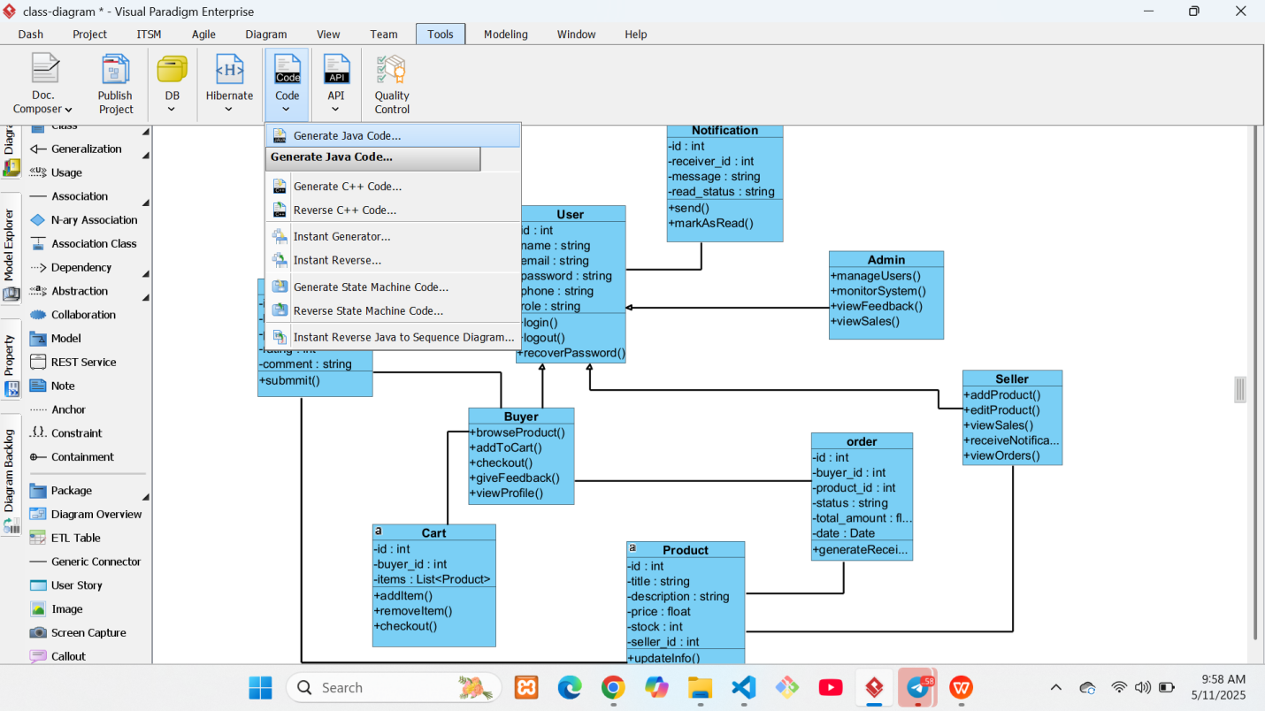

Figure : Steps to generate Java code class diagram

Step 4: Generate Code

Click the **Generate** button. Visual Paradigm will automatically create:

One source file per class

Files containing attributes and method stubs that reflect the diagram

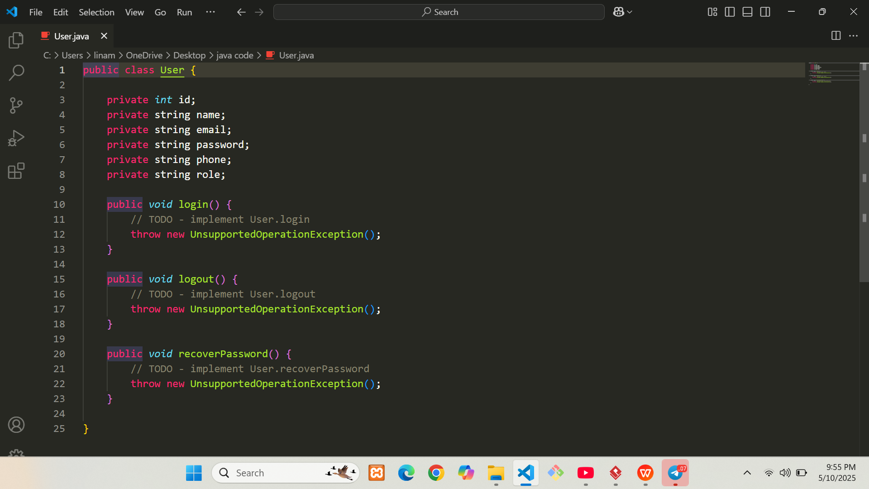

Figure : Generated Java code 1.

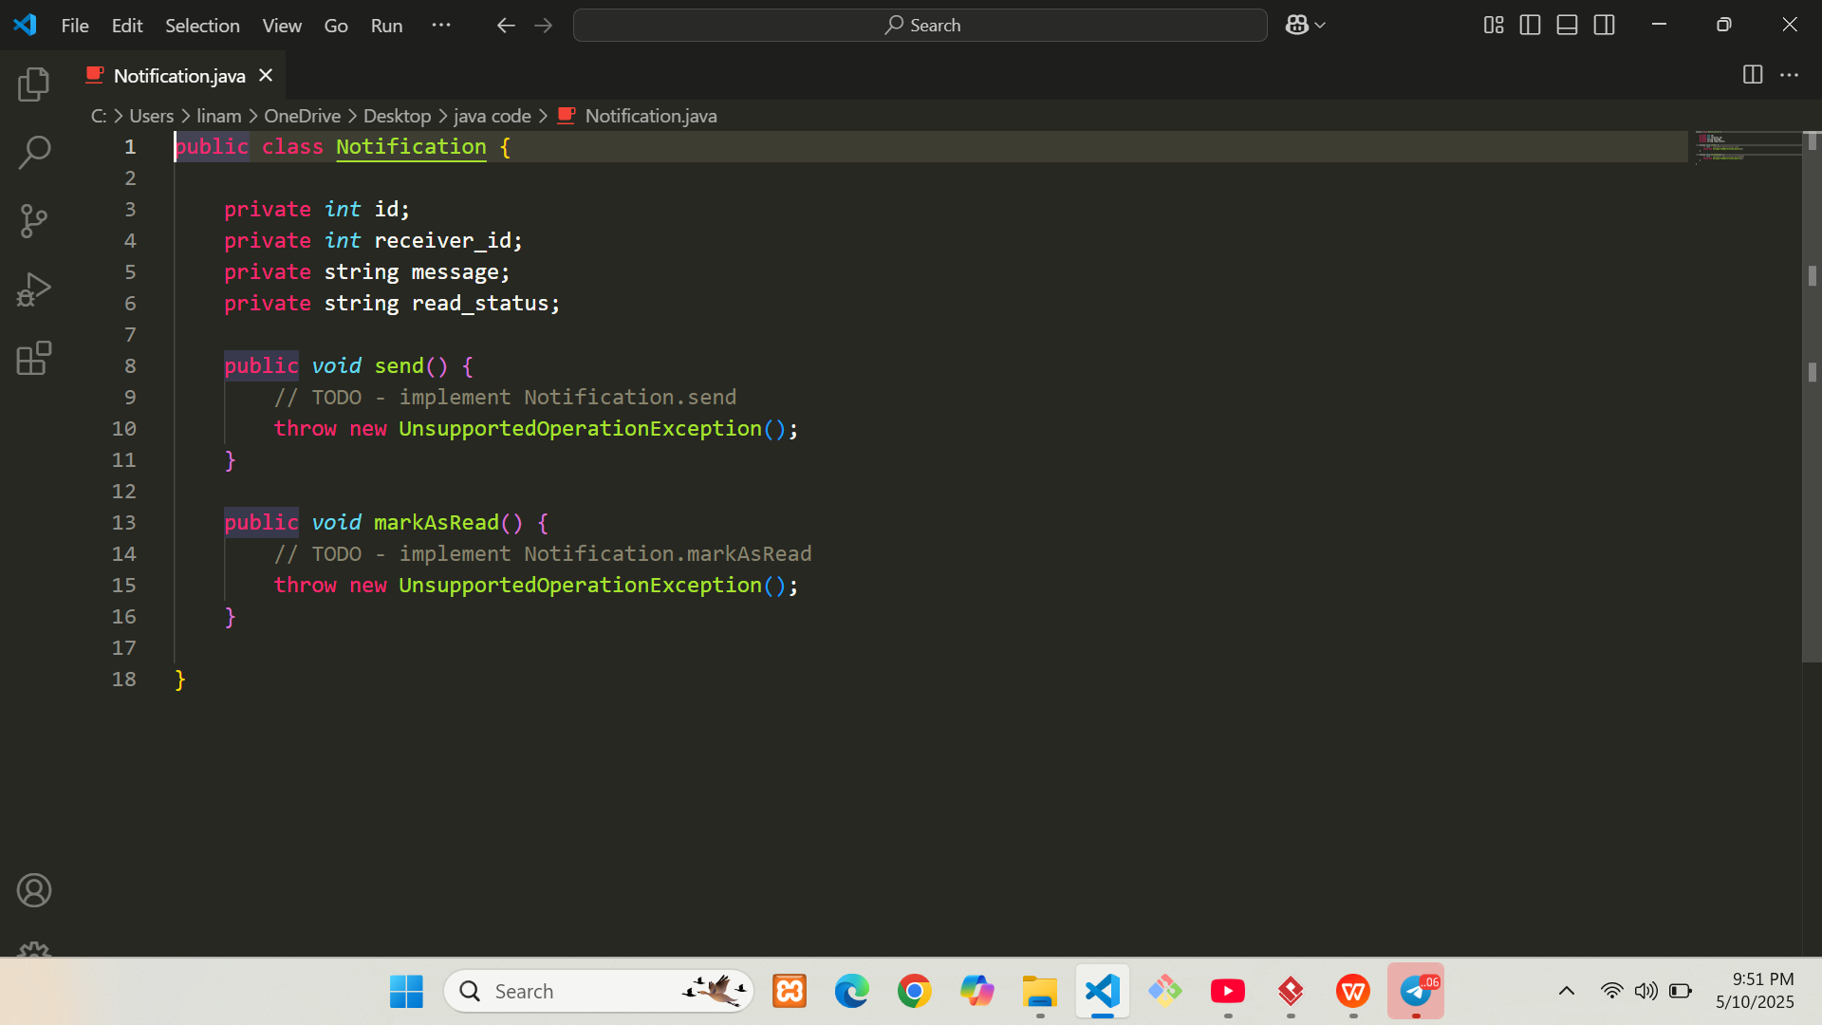

Figure : Generated Java code 2.

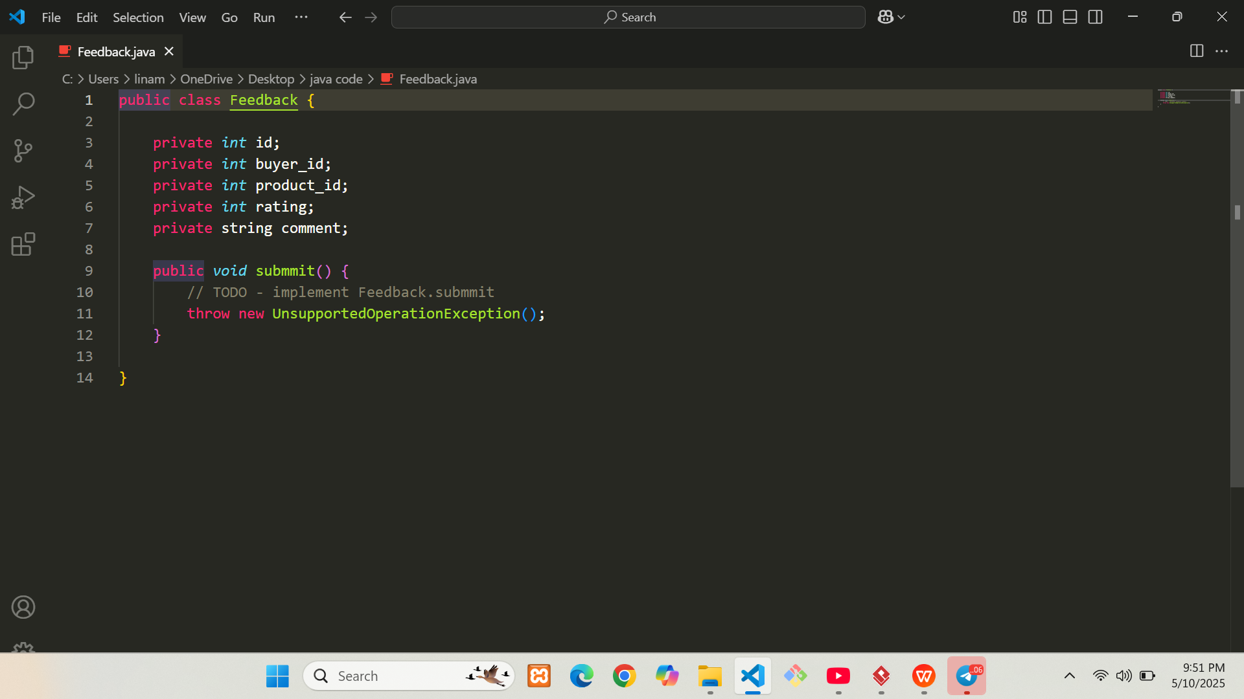

Figure : Generated Java code 3.

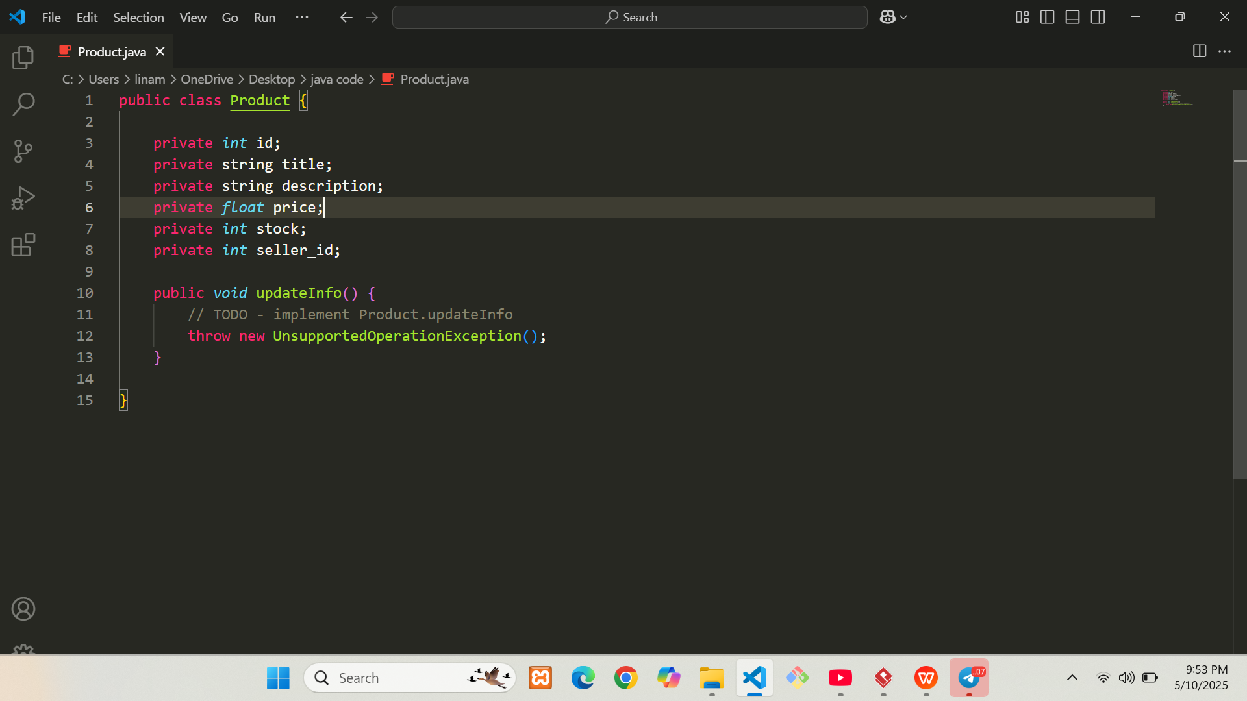

Figure : Generated Java code 4.

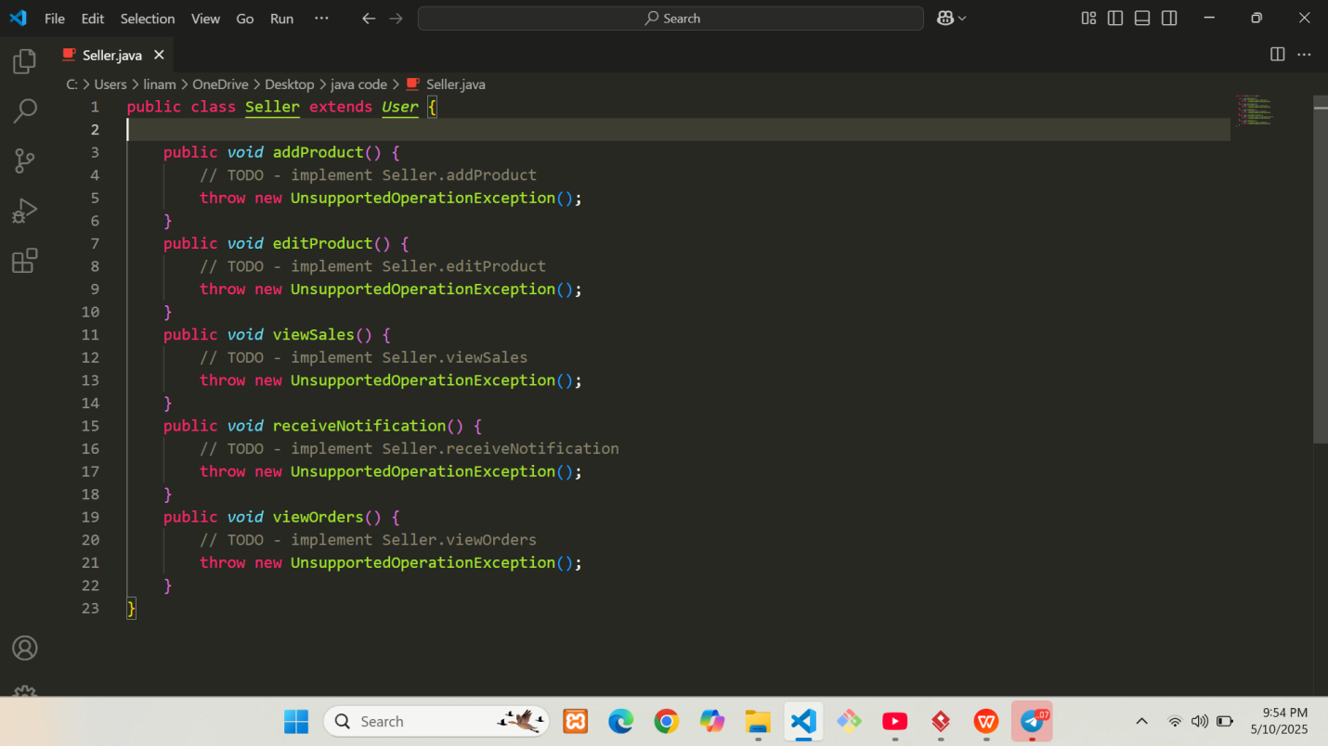

Figure : Generated Java code 5.

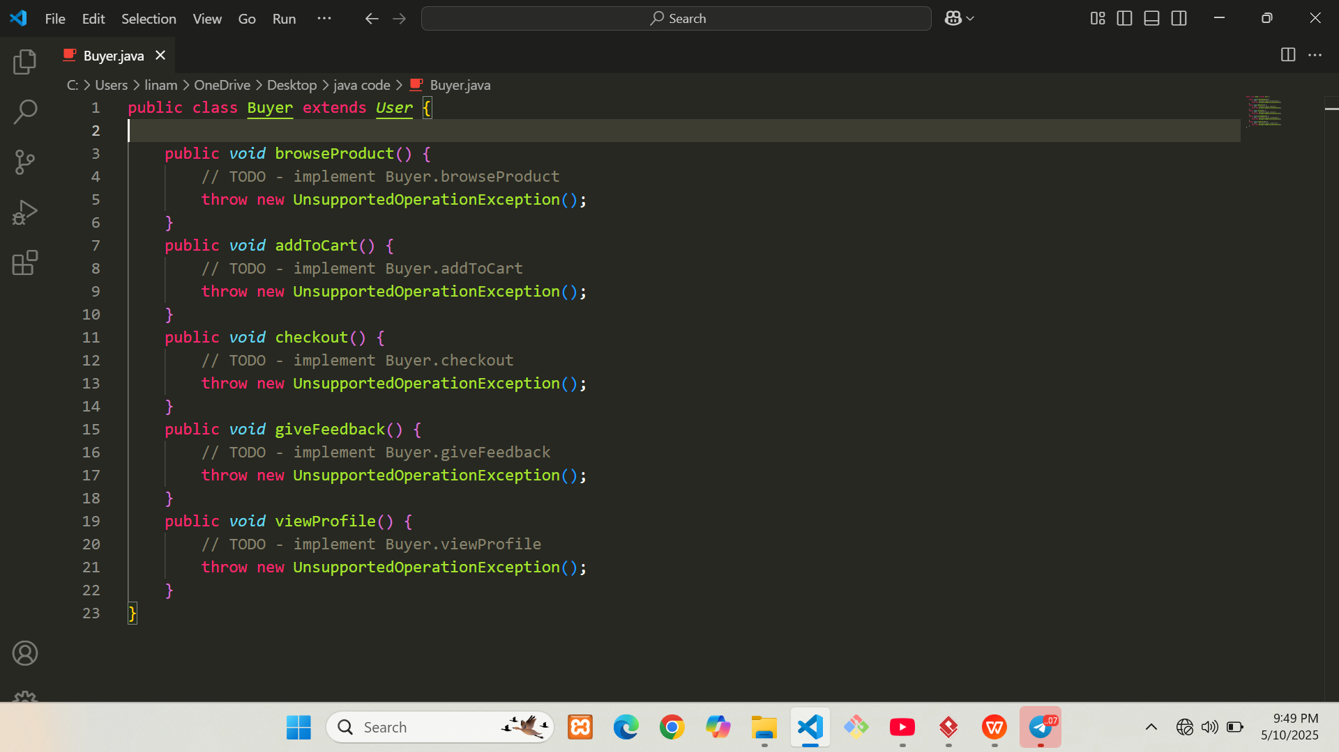

Figure : Generated Java code 6.

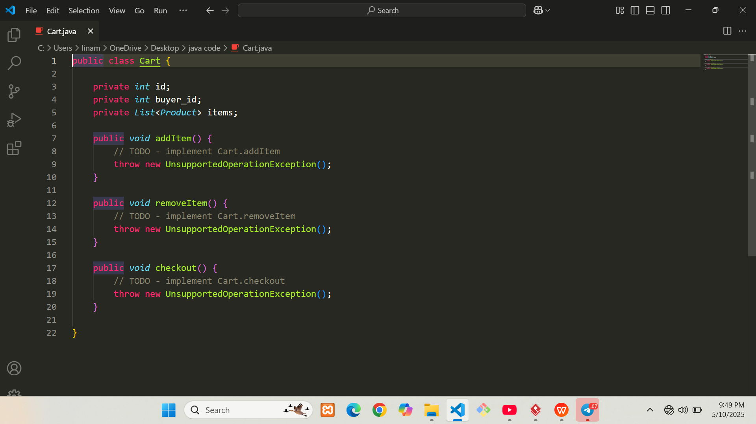

Figure : Generated Java code 7.

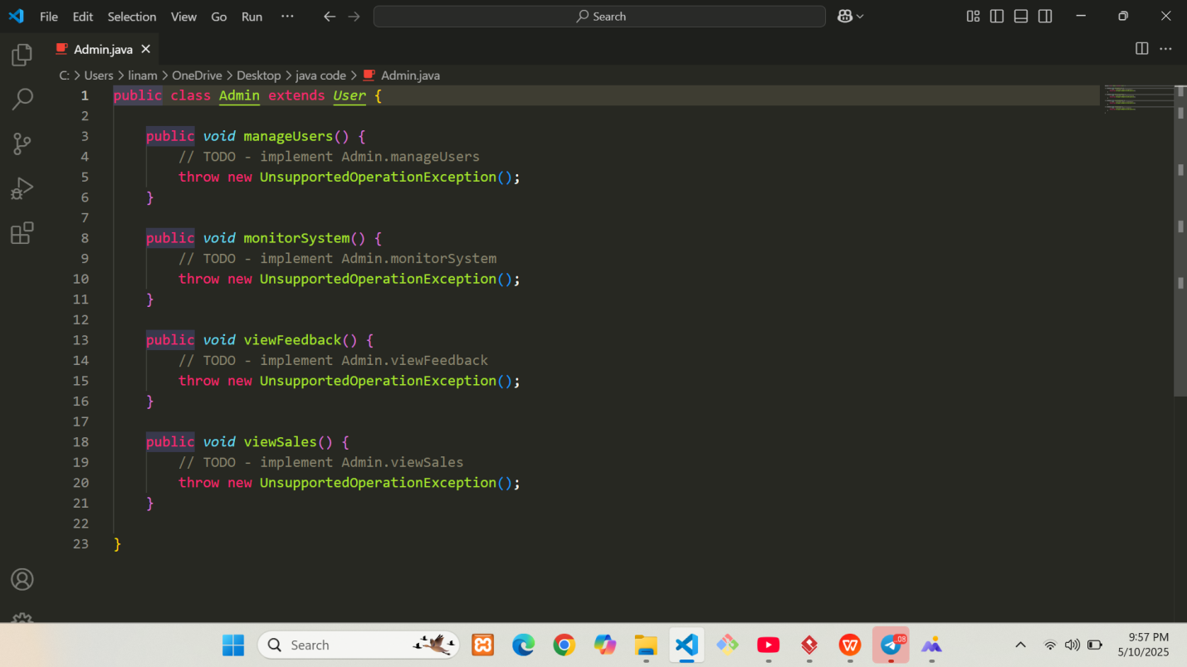

Figure : Generated Java code 8.

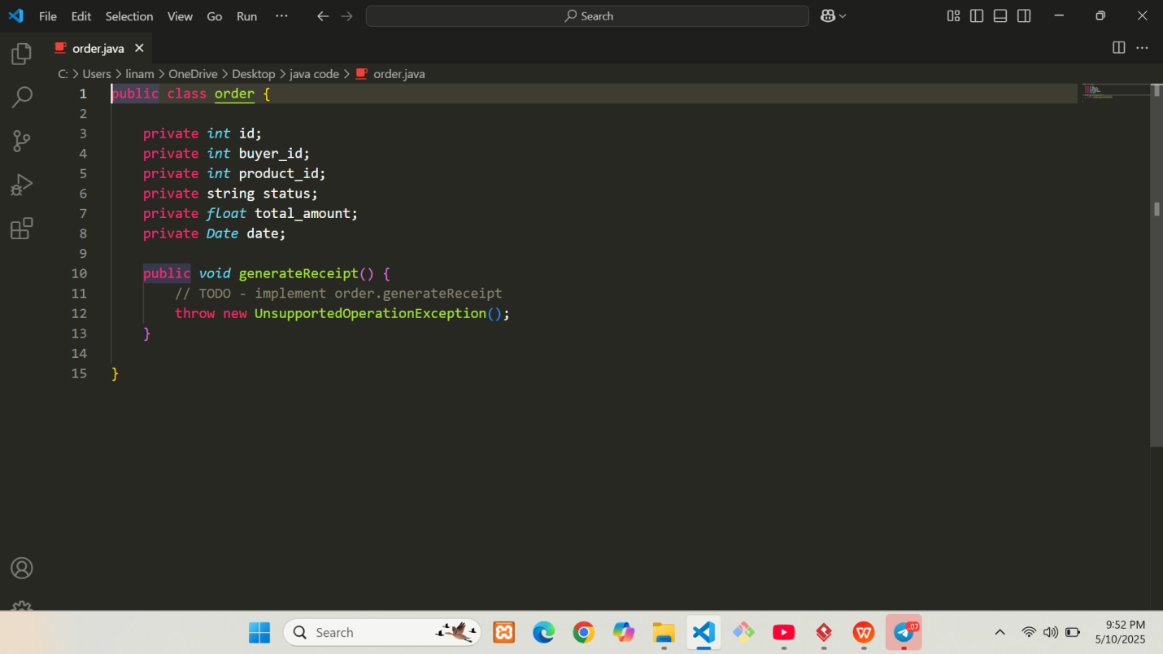

Figure : Generated Java code 9.

Step 5: Update and Sync

As development continues, changes in code may require updates to the class diagram

Use **reverse engineering** to import code changes back into Visual Paradigm:

**Tools > Code > Reverse Engineering**

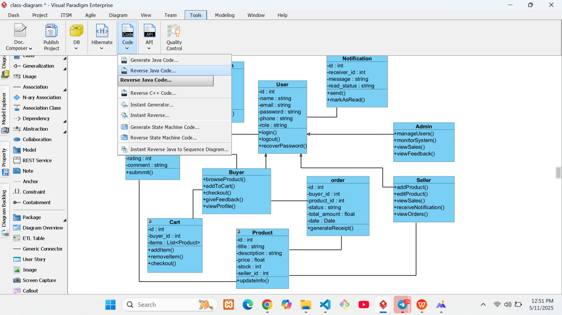

Figure : Step to show how to reverse a java code.

This process allows for a continuous feedback loop between the design and the implementation, supporting agile and iterative development practices.

# CHAPTER FIVE

## 5.1 Change Management (Version Control Using Git)

Effective change management is essential for maintaining code quality, collaboration, and traceability throughout the software development lifecycle. In this project, we adopted **Git** as our distributed version control system to manage changes in the source codebase.

**Git allowed us to:**

* Track the history of every file and line of code
* Collaborate as a team without overwriting each other's work
* Create and merge branches for feature development, bug fixes, and releases
* Revert to previous stable versions when issues occurred
* Maintain a clear, documented progression of the project

To complement Git, we used **GitHub** as our remote repository hosting service. GitHub provided a centralized platform for storing, reviewing, and sharing our codebase. It also enabled additional collaboration features such as pull requests, issues tracking, and project boards.

This approach significantly improved the maintainability and scalability of the project and allowed for seamless teamwork even in distributed environments.

## 5.2 Steps and Tools Used in Our Project to Implement Git

The following steps outline how Git and GitHub were integrated into our project workflow:

**Tools Used**

* **Git**: Installed locally to manage version control on each developer’s machine
* **GitHub**: Hosted the project repository online for team collaboration and backup
* **Git Bash**: Used for executing Git commands

**Steps Followed**

1. Initialize Git in the Project Directory

This set up Git tracking in our local codebase.

1. Create a Remote Repository on GitHub

* Repository created at <https://github.com/KedijaAnsha/software-tools.git>
* Default README.md and License were included

1. Link Local Project to GitHub Repository

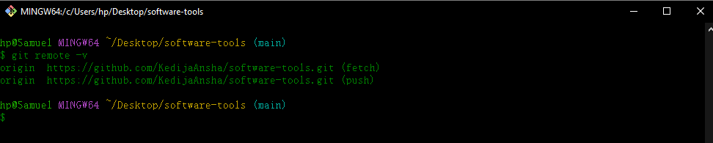

Figure : Link local to remote repository

1. Add and Commit Files

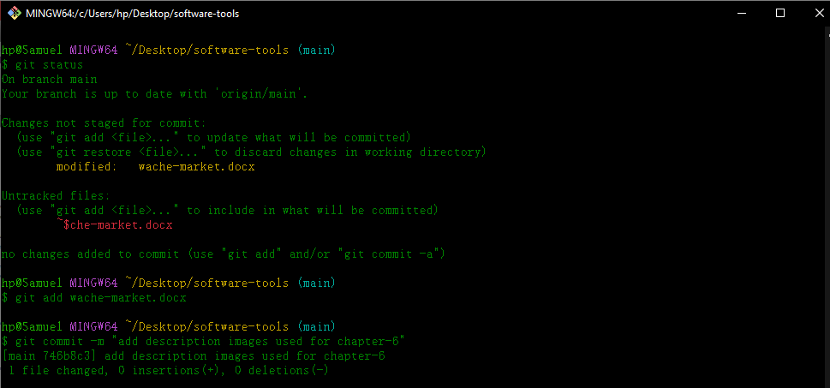

Figure : Add and Commit file changes.

1. Push Code to GitHub

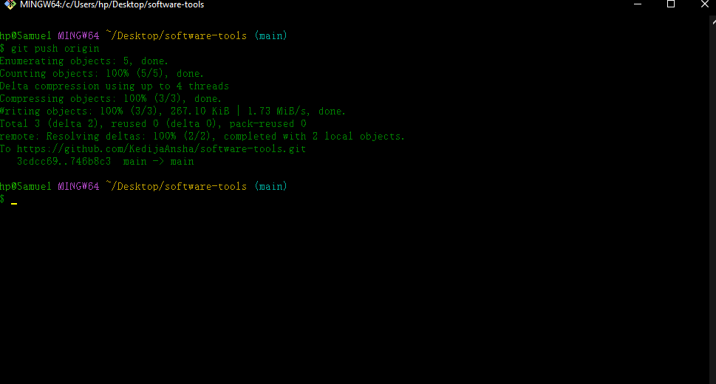

Figure : Push local changes to remote repository

1. Pull Requests and Code Reviews

* Reviewing code changes
* Discussing improvements

1. Conflict Resolution

This Git-based workflow ensured that our team maintained a clean, stable, and documented development process. All project members had real-time access to the latest code and could contribute without fear of overwriting each other's work.

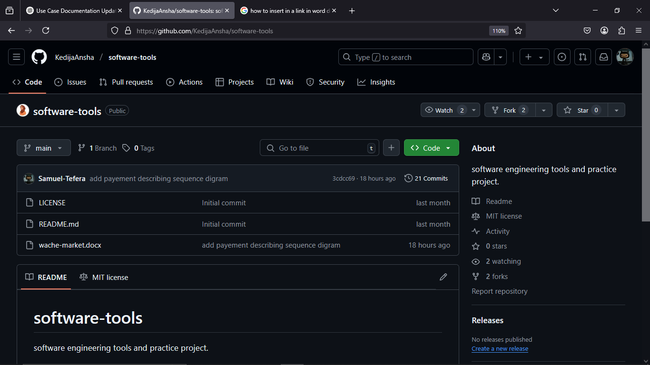

Figure : Remote repository

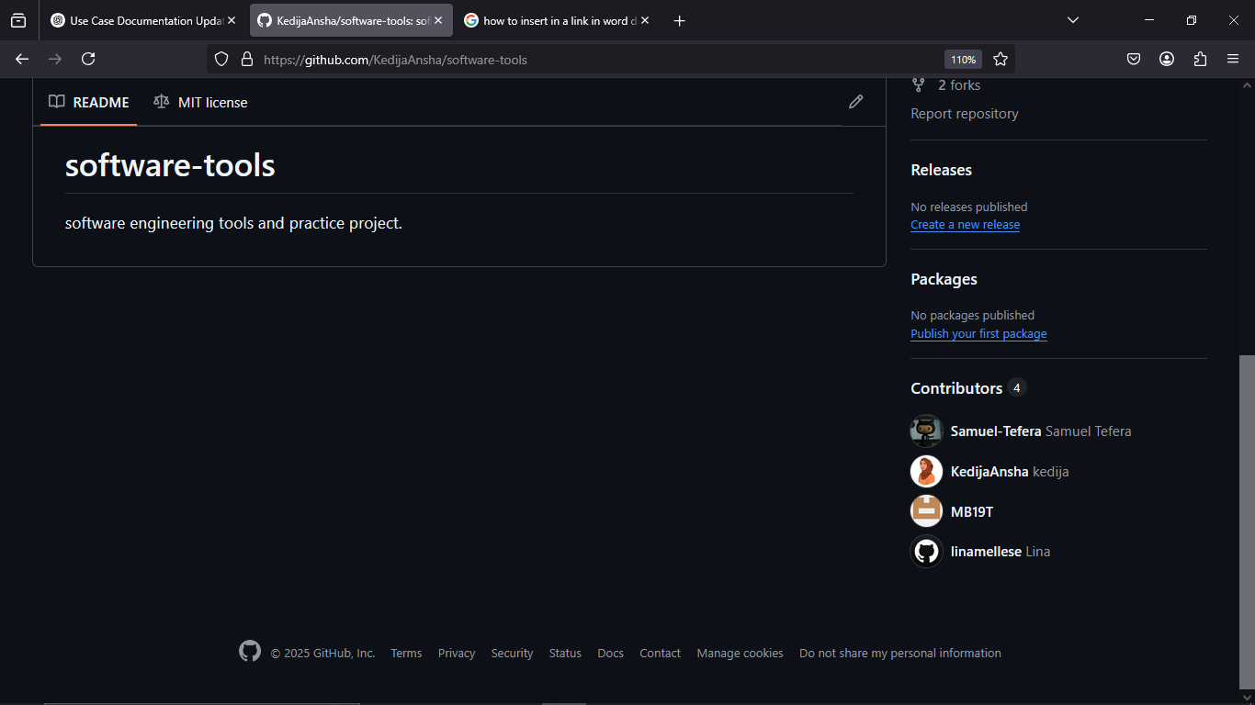

Figure : Contributors on remote repository.

# CHAPTER SIX

## 6.1 Unit Test

Unit testing is a vital process in ensuring that individual components of the software function as intended. In this project, **JUnit** was used in conjunction with **Eclipse IDE** to perform unit testing on core classes and methods of the e-commerce system.

**By testing each unit in isolation, we were able to:**

* Detect bugs early in the development process
* Validate the behavior of each method or logic block
* Refactor code safely with confidence
* Ensure ongoing reliability through automated test execution
* Facilitate safer refactoring and updates

Each test case was designed to test one specific functionality using expected inputs and validating outputs. If changes were made to the codebase, rerunning the unit tests ensured that existing features continued to work properly — helping prevent regressions.

**JUnit’s** seamless integration with **Eclipse** allowed developers to quickly write, execute, and monitor tests during development

## 6.2 Steps and tools used in Unit Test

In this project, unit testing was performed using **JUnit 5**, which is natively integrated into the **Eclipse IDE**. No additional installations or external configurations were required. The code under test was **automatically generated from the class diagram** created in Visual Paradigm, ensuring consistency between the system design and implementation.

This approach allowed the development team to efficiently validate the functionality of each class and method derived from the system’s object-oriented design.

**Tools Used**

* Eclipse IDE

Utilized for writing and executing unit tests within an integrated development environment.

* JUnit 5

The default unit testing framework bundled with Eclipse, used to verify correctness of class behaviors.

* Visual Paradigm

Used to design the class diagram and export Java class structures for testing

**Steps Followed in Unit Testing**

* 1. Generate Class Code from Diagram

The class diagram was modeled in Visual Paradigm, and the system’s classes were exported using the Instant Generator. The generated .java files (e.g., User.java, Product.java) were imported into Eclipse for testing.

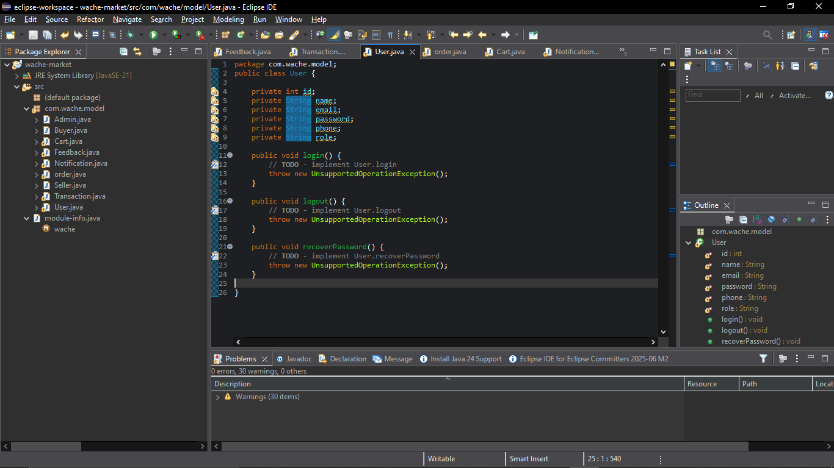

Figure : Steps to generate test code in java.

* 1. Create a JUnit 5 Test Class

In Eclipse:

* + - Right-click on the generated class → New > JUnit Test Case
    - Select **JUnit 5** as the version
    - Choose methods to test or add custom test methods manually

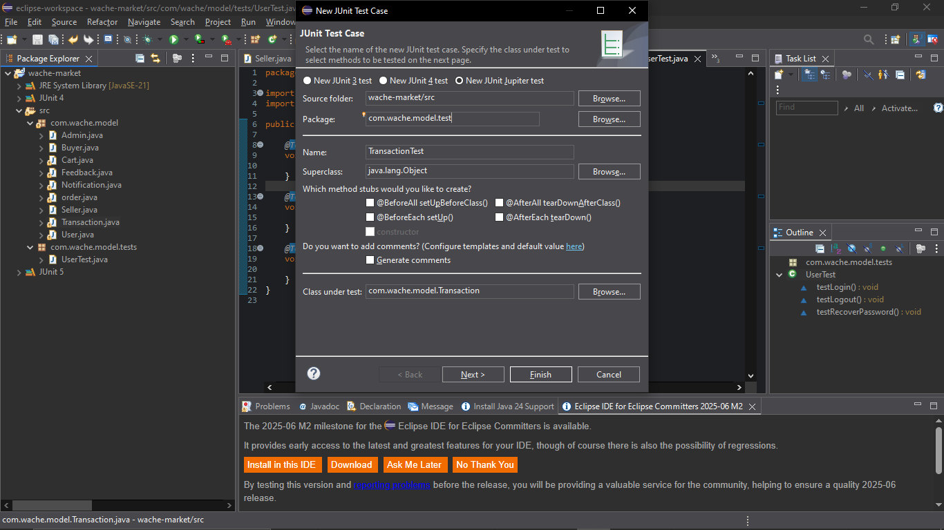

Figure : Steps to draw generate test code in java.

* 1. Write Test Methods

Each test method was annotated with @Test and contained assertions to validate expected outcomes.

Example:

package com.wache.model.tests;

import com.wache.model.User;

import org.junit.jupiter.api.BeforeEach;

import org.junit.jupiter.api.Test;

import static org.junit.jupiter.api.Assertions.*;

public class UserTest {

private User user;

@BeforeEach

void setUp() {

user = new User(1, "Alice", "alice@example.com", "password123", "1234567890", "user");

}

@Test

void testLoginSuccess() {

boolean result = user.login("alice@example.com", "password123");

assertTrue(result);

assertTrue(user.isLoggedIn());

}

@Test

void testLoginFailure() {

boolean result = user.login("alice@example.com", "wrongpass");

assertFalse(result);

assertFalse(user.isLoggedIn());

}

@Test

void testLogout() {

user.login("alice@example.com", "password123");

user.logout();

assertFalse(user.isLoggedIn());

}

@Test

void testRecoverPasswordSuccess() {

String response = user.recoverPassword("alice@example.com");

assertEquals("Password recovery link sent to alice@example.com", response);

}

@Test

void testRecoverPasswordFailure() {

String response = user.recoverPassword("bob@example.com");

assertEquals("Email not found.", response);

}

}

* 1. Run Tests in Eclipse
* Right-click on the test class or file → Run As > JUnit Test
* The Eclipse JUnit view displayed the test status using a **green bar** (success) or **red bar** (failure)

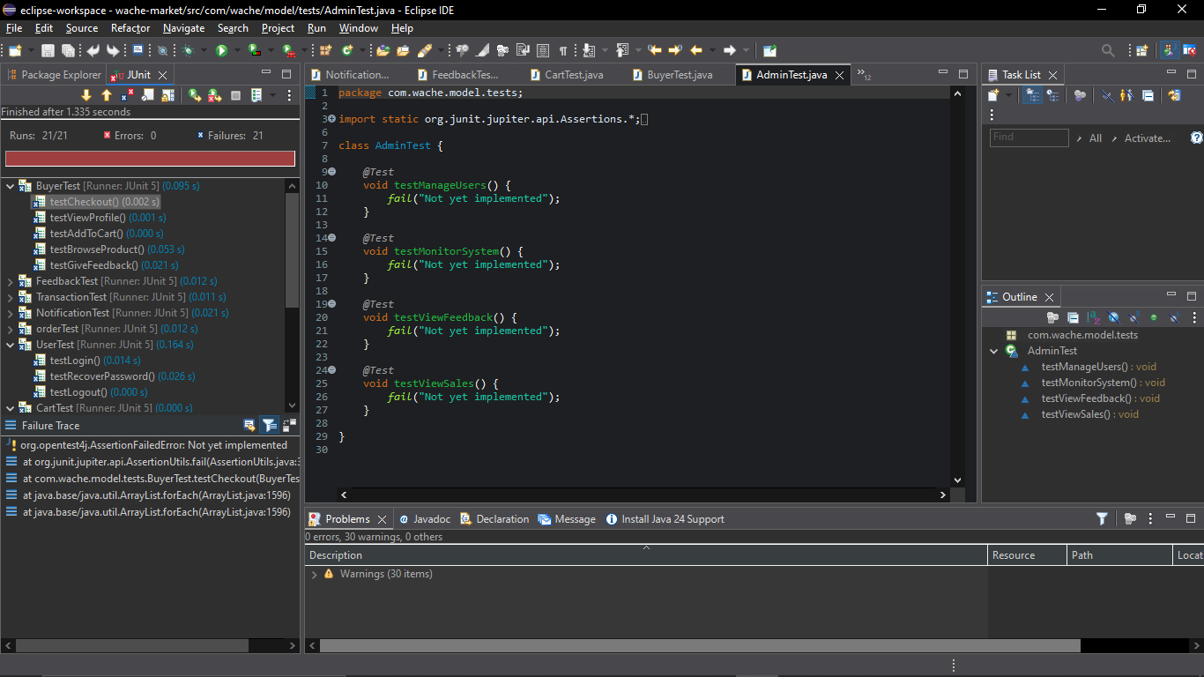

Figure : Steps to generate test code.

* 1. Review Test Results

The JUnit output panel provided:

* Pass/fail indicators
* Detailed failure messages
* Stack traces and error locations
* Execution times for each test

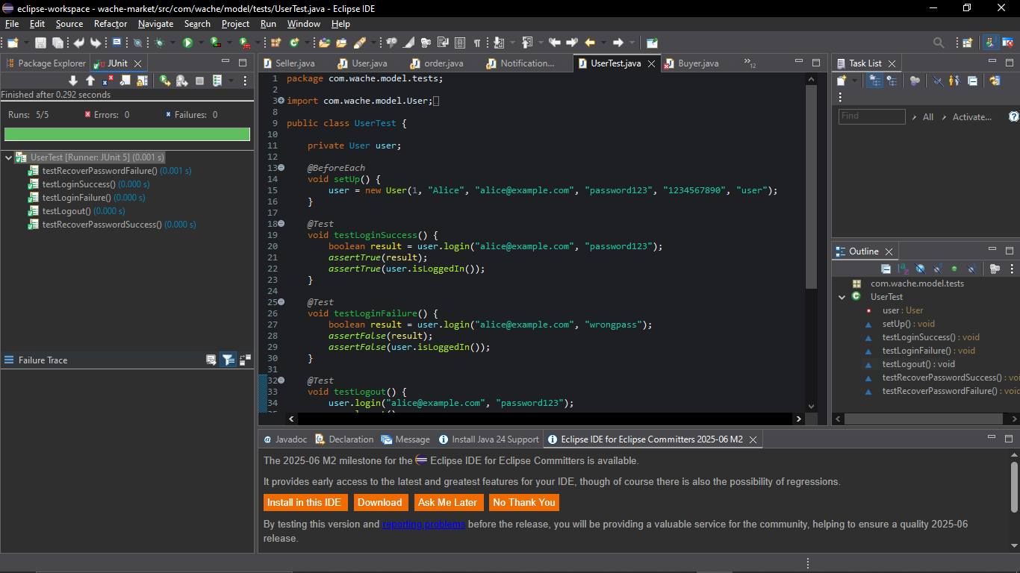

Figure : Steps to generate java code.

This structured approach ensured that all critical class behaviors were validated against expected results. By combining **code generation from the class diagram** with **built-in testing tools**, the team was able to streamline testing efforts and maintain a consistent, error-resistant codebase.

# CHAPTER SEVEN

## 7.1. Build (Prepare Build Script for Compilation, Unit Test, JAR File Creation)

The build process transforms the written source code into an executable format, ensuring that the application is compiled, tested, and packaged correctly. In this project, the build workflow included compiling Java source files, running unit tests, and creating an executable JAR file.

**This process ensured:**

* Consistency across builds
* Early detection of compile-time and logic errors
* A ready-to-deploy deliverable (.jar file)

Using Eclipse IDE and the Java Development Kit (JDK), we implemented a straightforward and repeatable build cycle that allowed developers to efficiently prepare the system for testing and deployment.

## 7.2. Steps and Tools Used in Our Project to Implement Build

**Tools Used:**

* Eclipse IDE: For source code editing, compiling, testing, and packaging
* Java Development Kit (JDK): Required to compile and run Java programs

**Steps Followed in Eclipse:**

1. Organize the Project

* Source code placed under the src/ directory
* JUnit test files placed in the same or a separate package

1. Compile the Code

* Eclipse automatically compiles .java files upon saving
* Compilation errors are shown in the "Problems" view

1. Run Unit Tests

* Right-click the test class → Run As > JUnit Test
* Confirm all tests pass before proceeding to packaging

1. Export to JAR

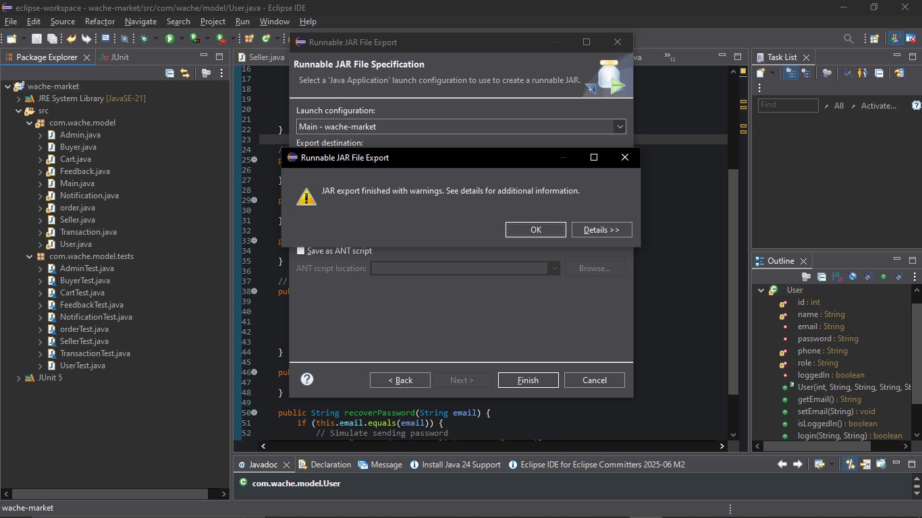

Figure : Steps to create jar file from java code.

* Right-click the project → Export > Java > Runnable JAR file
* Choose the launch configuration (select the main() class)
* Select a destination for the JAR file and configure library handling
* Click Finish to generate the .jar file

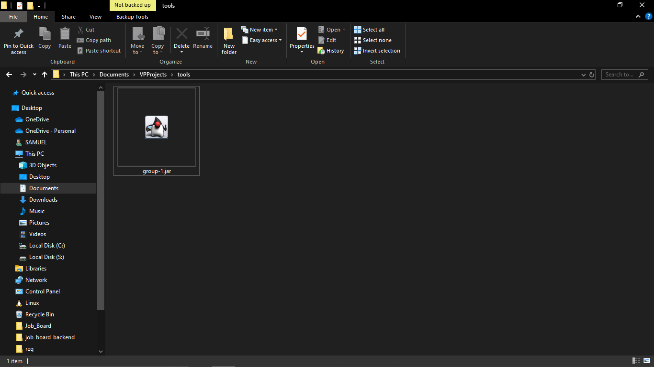

Figure : Jar file.

This build approach allowed for a simple yet effective workflow that ensured every project version was properly compiled, tested, and packaged using only Eclipse and JDK. This ensured quick deployment and reliable testing without the need for external build tools.

# References

1. Visual Paradigm. (2024). UML Modeling Tools. Retrieved from <https://www.visual-paradigm.com>
2. Eclipse Foundation. (2024). Eclipse IDE. Retrieved from <https://www.eclipse.org>
3. JUnit. (2024). Unit Testing Framework. Retrieved from <https://junit.org/junit5/>
4. Git. (2024). Version Control System. Retrieved from <https://git-scm.com>
5. GitHub. (2024). Project Repository Hosting. Retrieved from <https://github.com>
6. Oracle. (2024). Java Documentation. Retrieved from <https://docs.oracle.com/javase/8/docs/>
7. Lab and Module materials provide from course instructor.